

Reports

CE Version 3.3.6

July 2021  
Document Release 1.0

|  |
| --- |
| EXIMBILLS © Trade Finance System  Customer Enterprise System Version 3.3.6  Reports  July 2021 |
| *Copyright 2021 © China Systems Corporation*  *All Rights Reserved*  *This document is protected by United States Copyright Law and may contain Trade Secrets Information which is proprietary to China Systems Corporation. No part of this document may be copied, photocopied, reproduced, translated, distributed, or reduced to any electronic medium or machine-readable form without prior consent in writing from China Systems Corporation. The information in this document may be used only under the terms and conditions of separate China Systems Corporation license agreements.*  *Information is subject to change without notice. China Systems Corporation makes no warranties, either expressed or implied, with respect to the software herein described as to its quality, performance, including, without limitations to, its fitness for any particular purpose.*  *This document may not reflect total system capability at any subsequent date as a result of development. It is also possible that it may contain references to facilities not available on your computer system. Such references should not be construed to mean that these facilities will necessarily be made available on all types of computer hardware or in all user locations.*  *China Systems Corporation accepts no responsibility or liability for any damages or loss of business or revenue due to the use of this document.*  *All trademarks, registered trademarks and trade names mentioned in this document are the sole property of their respective holders.* |
| ORDER MORE EXIMBILLS DOCUMENTATION  Additional copies of Documentation are available for purchase from China Systems Corporation or through your local EXIMBILLS Support Office. |
| csliit  CHINA SYSTEMS CORPORATION  Comments may be addressed to:  [corporatedocs@chinasystems.com](mailto:corporatedocs@chinasystems.com)  China Systems Corporation Ltd.  Corner House, 20 Parliament Street  Hamilton HM12  Bermuda |

Table of Contents

CE Documentation Library 6

CE Documentation Library 7

Core System Manuals 7

CE Utility Reference Manuals 10

Installation Guides 10

Introduction 11

System Overview 12

Manual Overview 13

Using the CE Utility 14

Running the CE Utility 15

Preparing the CE Utility Files 15

Accessing the CE Utility 17

Navigating the CE Utility Interface 21

CE Utility Functions 22

Menu Bar 25

Toolbar Buttons 27

Popup Menu 32

Generating the XML Parameter Files 33

Building a Product 37

System Requirements 39

Required Files 40

Program Files and Folders 41

BIRT Versions 42

BIRT Logs 43

BIRT Deployment 47

Deploying the BIRT EAR File 47

Configuring Other BIRT Settings 51

Installing CE and BIRT on the Same Application Server 56

Installing CE on Separate Application Servers 64

BIRT Report Templates 68

Creating the Report Template File 68

Connecting to a Data Source 73

Defining the Data Sets 79

Designing the Report Template 84

Layout Editor 84

Palette View 88

Using Data Set Fields in the Template Layout 95

Producing CE Documents 96

Overview 97

Parameter Settings 99

Defining the Output Directory 99

Configuring the CE Report Template 101

Configuration 101

Creating the Report Template 102

Importing the Report Template to the Transaction Data Source 107

Procedure 108

Creating the Document Form 111

Configuration 111

Form Rule Configuration: Basic Information 112

Form Rule Configuration: Mapping Information 114

Procedure 119

Setting up the Transaction Function 123

Setting up the Product Function 124

Generating the XML Files 128

Producing CE Transaction Reports 132

Overview 133

Parameter Settings 134

Configuring the CE Report Template 134

Configuration 134

Creating the Report Template 135

Importing the Report Template to the Transaction Data Source 137

Mapping the Parameters to the JSP Fields 137

Procedure 139

Setting up the Transaction Function 143

Function Information 143

Screen Settings 144

Setting up the Product Function 146

Generating the XML Files 150

Special Report Functionalities 153

Using Different E-mail, Catalog Export, and Report Templates Per Entity 154

Configuration 154

Procedures 160

Mail Templates 161

Catalog Export 166

Report Template 171

Glossary 176

Glossary 177

CE Documentation Library

CE Documentation Library

CE Documentation Library

The CE Documentation Library lists all available manuals that serve as references on the use of the Customer Enterprise system. The documents are categorized into three groups: Core System Manuals, CE Utility Reference Manuals, and Installation Guides.

Core System Manuals

TheCE core system manuals provide details on the setup and configuration of various CE parameters, as well as the implementation of supplementary functionalities supported by the system.

Archiving and Recovery

This manual is a reference to the Archive and Recovery functionality of the CE system. Discussions include the required parameter settings for configuring the relevant functions, as well as examples of how this functionality is used in transaction processes.

Building a Product

This manual is a reference to the process of building a product in CE. It provides step-by-step procedures on how to create a basic CE module, transaction function, and product setting; configure parameters; and attach components to generate a working business product.

Data Objects

This manual serves as a reference for creating and utilizing data objects in the CE system. The discussions provide details on how to build data object templates and data object entities, and how to attach these to the transaction function screen.

Frequently Asked Questions

This document addresses commonly-asked questions on the Customer Enterprise system. Issues on the browser-side (transaction processing), CE Utility, Security Module, and database, among others, are addressed in the discussions.

Interfacing CE with CS Eximbills

This document discusses the process of interfacing CE with the CS Eximbills (CSX) back office system. Employing the MQ, FTP, and TCP/IP communication protocols, the interface process using the XML format is detailed in this document.

Interfacing CE with Eximbills Enterprise

This document discusses the process of interfacing CE with the Eximbills Enterprise (EE) back office system. Employing the MQ protocol, the interface process for the transfer of data between CE and EE using the XML format is detailed in this document.

Log Settings

This manual provides details on CE logs as well as general instructions on log configuration in CE. This is especially written for the users who are in charge of maintaining the CE system.

Look and Feel

This manual is a reference guide on designing the CE user interface (i.e., the look and feel of the system). Divided into two parts, the manual provides instructions on creating a) the basic L&F style of CE; and b) the CE L&F style that incorporates widgets.

Multi-Entity

This manual is a reference on implementing the Multi-Entity functionality of the CE system. Discussions cover the implementation and application of CE multi-entity.

Multi-Language

This manual discusses the procedures required in setting up the Multi-Language functionality of CE as it is run by Administrator- and Operator-type users. Furthermore, the configuration of certain system and browser elements as well as the setup of related system parameters is explained in step-by-step procedures.

Reports

This manual is a comprehensive reference guide on the requirements and processes involved in building business products and functions that generate online reports and documents.

Security and System Maintenance Functions

This manual is a comprehensive guide on the security and system maintenance of the CE system. As such, it includes detailed instructions for company and company function management, and user and user function management. Maintenance of key functionalities such as authorization rules, reference numbers, and other services is covered as well. In addition, this document discusses the security concepts in CE to assist users assigned with access rights to the CE Security Module.

Standing Data Functions

This document discusses the functions for the CE standing data that are maintained by operators (e.g., parties, clauses). It includes sections for each function, starting with a brief description of the function, followed by the function input when necessary, and the procedure steps.

Supplementary Functions

This manual is a reference for the CE Utility operator user in configuring parameter, JSP, and transaction function settings to define special or supplementary CE functionalities such as uploading images; sending images and forms to the back-office system; and sending notifications via e-mail, SMS, and widgets.

System Administration Functions

This manual is a reference for the default Super Administrator user of the CE Utility in the configuration and maintenance of the CE environment. It discusses in detail user management and parameter management.

System Reference

This document serves as a quick reference to the following elements that are used when configuring specific parameters in the CE Utility: global system parameters, system parameters, components, XML Generator items, server side system methods, system JS methods, and APIs.

CE Utility Reference Manuals

The CE Utility Reference set of manuals is a guide on the use of the Customer Enterprise Utility Workbench, or simply CE Utility. This reference provides information on every function or feature in the CE Utility and includes instructions and step-by-step procedures on how to operate or use the function in relation to operating and maintaining the CE system and processing a business transaction.

A manual is provided for each function group of the CE Utility:

* *CE Utility Reference: User Manager Functions*, for the functions that belong to the User Manage function group of the CE Utility when accessed by an Administrator or Operator user
* *CE Utility Reference: Parameter Manager Functions*, for the functions that belong to the Parameter Manage function group of the CE Utility when accessed by an Administrator or Operator user
* *CE Utility Reference: System Functions*, for the functions that belong to the System Function group of the CE Utility.
* *CE Utility Reference: Transaction Functions*, for the functions that belong to the Transaction Function group of the CE Utility.
* *CE Utility Reference: Product Functions*, for the functions that belong to the Product Function group of the CE Utility.
* *CE Utility Reference: Maintenance Functions*, for the functions that belong to the Maintenance function group of the CE Utility.

Installation Guides

TheCE installation guides are references on the installation and setup processes of the CE system on different application servers and databases.

Installation Guide WAS 9 - Oracle 19c

This is a reference for installing the CE system on WebSphere Application Server Version 9.0.5.6, with an Oracle 19c database. This includes detailed instructions on configuring the components that are required to successfully run CE.

Introduction

SYSTEM OVERVIEW

MANUAL OVERVIEW

Chapter One

System Overview

The Business Intelligence and Reporting Tools, BIRT, is one of the most frequently used and practical reporting services. An Eclipse-based open source reporting system for web applications, BIRT provides a variety of reporting design options and report patterns in different file output formats.

The BIRT tool is the primary report engine integrated with CE. Through the separately designed BIRT templates and parameter settings in CE, the relevant CE data is passed to the BIRT application, which in turn, facilitates the generation of reports and documents.

Through this reporting interface between CE and BIRT, the following functionalities are supported:

* The PDF, EXCEL, and DOC (WORD) report and document formats are supported.
* Reports can be generated dynamically according to parameter values defined at function setup or at runtime.
* A standalone function for producing online transaction reports can be defined.
* Batch reports are supported.

With the BIRT report engine, the CE system can support online and offline report and/or document generation. Online reports and documents are generated at runtime, such as upon transaction confirmation. Offline reports, on the other hand, are produced in batches according to a defined schedule in which all report data are collected.

Documents can also be generated as e-mail attachments that are sent out in batches.

Manual Overview

**Purpose**

This manual is a comprehensive reference guide on the requirements and processes involved in building business products and functions that generate online reports and documents. This manual also covers basic BIRT settings.

This document is written with the assumption that the CE environment has already been successfully installed and the reader has sufficient knowledge of the following:

* Building a CE product; and
* Using the BIRT application, installing BIRT, and designing BIRT report templates.

**Audience**

This manual is a reference specifically for, but not limited to, the following users:

* Consultants responsible for creating and configuring reports and document outputs
* Bank or browser-side users tasked to process transactions involving reports.

**Prerequisites**

* Recommended references before reading this manual: *CE Building a Product, CE Installation Guide, and CE Utility References*

NOTE: Some features discussed in this manual have been tested and documented based on an older system version. Unless otherwise specified, the overall functionality is the same when recreated in the current version.

Using the CE Utility

Chapter Two

* RUNNING THE CE UTILITY
* GENERATING THE XML PARAMETER FILES
* BUILDING A PRODUCT

Running the CE Utility

The Customer Enterprise Utility Workbench, or CE Utility, is the main tool for building parameters in CE.

Preparing the CE Utility Files

Along with the installation files, the CE Utility folder is provided with every CE system release. Prior to using the CE Utility, do the following:

1. Copy the CE Utility folder to the local drive.
2. Define the required environment variables.
3. Map the CE directories (e.g., CEWeb.war and CE_PARA) to the network drive.

|  |
| --- |
|  |

***Figure 2. 1 CE Utility Folder***

**noteNOTE:**

1. The default drives defined in the GEN_XML_ROOTPATH and GEN_WEB_ROOTPATH system parameters are O:\ and P:\ respectively. These drives, if currently not existing, may be created through a batch file. While O:\ and P:\are the default drives for CE, these may be set to any other preferred drive available in the network.
2. To enable users to use the CE Utility on their own local machines as clients connecting to the CE server: 1) Install the Java Development Kit (JDK) program; 2) Copy the CE Utility folder; 3) Create the JAVA_HOME environment variable, which must point to this directory: [Java Home]\[Installed JDK].
3. For more information on setting up the CE environment, refer to the CE installation guides*.*
4. For information on the CE Utility functions, refer to the *CE Utility Reference* manuals.

|  |
| --- |
| **Batch File for Creating the CE Drives**  The batch file for creating drives contains the following commands:  subst O: /d  subst P: /d  subst O: C:"\Program Files\IBM\WebSphere\AppServer\profiles\AppSrv01\installedApps\DOCS-CEV336Node01Cell\CE.ear\CE_PARA"  subst P: C:"\Program Files\IBM\WebSphere\AppServer\profiles\AppSrv01\installedApps\DOCS-CEV336Node01Cell\CE.ear\CEWeb.war" |

Accessing the CE Utility

The main program for running the CE Utility is the CEUtility.bat file, which is found in the CE Utility folder.

|  |
| --- |
| **Do the following . . .** |

|  |  |  |
| --- | --- | --- |
| 1. Run the CEUtility batch program to access the CE Utility.  **NOTE**:  A shortcut for the CEUtility batch file can be created on the desktop for easy access. |  |  |
|  |  |  |
| 2. The logon window of the CE Utility is displayed.  To define the database information, click on the Profile button. |  |  |
|  |  |  |
| 3. In the Database Information dialog box that is displayed, specify the required database details and click on the Save button. |  |  |
|  |  |  |
| 4. A confirmation message is displayed. Click on the OK button. |  |  |
|  |  |  |

|  |  |  |
| --- | --- | --- |
| **NOTE**:  This new data source setting is saved in the UserInfo.xml file in the CE Utility directory. |  |  |
|  |  |  |
| 5. The relevant username and password may then be specified for logging on the CE Utility.  **NOTE**:  For information on defining CE Utility user profiles, refer to the *CE System Administration Functions* manual. |  |  |
|  |  |  |
| 6. The CE Utility window is displayed. |  |  |
|  |  |  |

|  |  |  |
| --- | --- | --- |
| 7. A function is accessed by opening or double-clicking on the relevant function group and clicking on the function name.  **NOTE**:  A user may only access and utilize the functions assigned to him. For more details, refer to the *CE Utility Reference: User Manager Functions* documentation*.* |  |  |

**noteNOTE:** It is sometimes necessary to assign a new user name and password when the new database is restored from a backup file. Restoring the backup file restores the original user profiles.

The new user profiles for the CE Utility (as well as the CE Security Module) can be defined during the installation process. SQL scripts are run to create these profiles. Refer to the CE installation guides for more information.

Navigating the CE Utility Interface

After logging on, the CE Utility window is displayed and parameters may then be configured. The functions used for setting up parameters may be accessed by clicking on the function name on the Function menu or by using the shortcut buttons.

The CE Utility interface also provides ways by which parameters can be created, edited, deleted or linked to other operations: menu bar, toolbar buttons, and popup menu.

|  |
| --- |
|  |

***Figure 2. 2 The CE Utility Interface***

note**NOTE:** A function is only displayed, and its corresponding button or menu option enabled, if the user has been given the right to access this function. Some options and functions are only available to Super Administrator users, while others are only accessible to Administrator and Operator users.

CE Utility Functions

The functions that may be accessed for setting up parameters are organized together into several function groups. The current available function groups and their corresponding functions in the CE Utility are as follows:

**User Manager Function Group**

This function group is comprised of functions used for creating, configuring, and exporting Bank-Country group settings; creating new users; and configuring data sources. These functions are:

* Business Unit Config
* DataSource Manage
* Import/Export Business Unit
* User Manage

**Parameter Manage Function Group**

This function group consists of functions used for maintaining system-wide parameters and components. These functions are:

* AP Server
* Component Manage
* Language Configuration
* System Parameter
* System Parameters

**System Function Group**

This function group consists of functions used for maintaining and facilitating system-wide tasks, operations, and settings. These functions are:

* Image Type Maintain
* Output Device
* Queue Manager
* STP Setting
* Time Zone

**Transaction Function Group**

This function group is comprised of functions used for defining the actual business parameters of transaction functions. These facilitate the maintenance and processes of the business transaction modules. These functions are:

* Amount/Rate Format
* Batch Manage
* Clause
* DO Get Data
* Export Setting
* Form
* GAPIs Setting
* Get Data
* Image Control
* Message Broker Setting
* Module & Event
* Report Template
* STPs Mapping
* Sub Tasks
* SWIFT Config
* System Maintain
* Transaction Function
* Transfer To
* TSU Mapping
* Upload Message Setting
* Web Service Setting
* Widget Maintain

**Product Function Group**

This function group consists of functions that are used for creating and configuring the products to be accessed and used by the customers or end-users. These functions are:

* Fields Select
* Inbox
* Product Authorize
* Product Authorize Setting
* Product Catalog
* Product Function Setting
* Product Item

**Maintenance Function Group**

This function group is comprised of functions used for facilitating the maintenance of data from CE tables, including fields and error settings. These functions are:

* DB Dictionary
* Error Handling
* Error Message Config (CE)
* Field Conversion
* Multi Language
* Page Dictionary
* XML Generator

Menu Bar

The options on the menu bar are shortcuts to both the common and specific functions and tasks of the system.

|  |
| --- |
|  |

***Figure 2. 3 Menu Bar***

|  |  |  |
| --- | --- | --- |
| **Menu** |  | **Description** |

|  |  |  |
| --- | --- | --- |
| **File** |  | The available options in the File menu are:   * New: This is used for creating a new parameter or rule. * Save: This is used for saving the created or modified settings. * Close Function: This is used for closing the current function window. * Connect To: This is used for connecting to another Meta data source. * Log Off: This is used for logging off a user that is logged on to the system without exiting the system. * Exit: This is used for closing the system window and exiting the system. |
|  |  |  |
| **Edit** |  | The available options in the Edit menu are:   * Add: This is used for adding a setting for the selected function or parameter. * Delete: This is used for deleting or removing an existing setting. * Edit: This is used for editing or modifying existing settings. * Copy: This is used for copying or duplicating a selected setting. * Find: This is used for finding a specific setting. |
|  |  |  |
| **Function** |  | The available options in the Function menu are:   * User Manage, which displays options for running User Manager functions * Parameter Manage, which displays options for running Parameter Manager functions * System Function, which displays options for running System functions * Transaction Function, which displays options for running Transaction functions * Product Function, which displays options for running Product functions * Maintenance, which displays options for running Maintenance functions |
|  |  |  |
| **Tools** |  | The available options in the Tools menu are:   * Toolbar: When this option is marked, the toolbar is displayed on the CE Utility Workbench window. * Function Toolbar: When this option is marked, the function toolbar is displayed on the CE Utility Workbench window. * Set User Profile DB Info: This option is used by the Super Administrator user to change the user information that is to be used by the CE Utility for connecting to a database. * Window Style: Selecting this option displays a list of CE Utility interface styles: Microsoft Style, Unix Style, Java Style, Classic Style, and Metal Style. The preferred style may be marked accordingly. |
|  |  |  |
| **Help** |  | The available options in the Help menu are:   * Help Topics: This is *currently not used*. * Content Help: This is *currently not used.* * About Customer Enterprise: Selecting this option displays the About Customer Enterprise window, which indicates the version information of CE. |

Toolbar Buttons

There are two kinds of toolbars in the CE Utility: the basic toolbar and the function toolbar.

**Basic Toolbar**

The following standard buttons are available on the Basic Toolbar of the CE Utility window. These are used for performing the basic and common tasks of the system.

|  |
| --- |
|  |

***Figure 2. 4 Basic Toolbar Buttons***

|  |  |  |
| --- | --- | --- |
| **Button** |  | **Description** |

|  |  |  |
| --- | --- | --- |
| **New** |  | This button is used for creating a new parameter or rule. |
|  |  |  |
| **Add** |  | This button is used for adding a setting for the selected function or parameter. |
|  |  |  |
| **Save** |  | This button is used for storing created or modified settings. |
|  |  |  |
| **Edit** |  | This button is used for editing or modifying existing settings. |
|  |  |  |
| **Copy** |  | This button is used for copying or duplicating a selected setting. |
|  |  |  |
| **Delete** |  | This button is used for deleting or removing an existing setting. |
|  |  |  |
| **Find** |  | This button is used for finding an existing setting. |
|  |  |  |
| **Close Function** |  | This button is used for closing a function window. |
|  |  |  |
| **Help Topic** |  | This button is *currently not used.* |
|  |  |  |
| **About Customer Enterprise** |  | This button is used for displaying the version information of Customer Enterprise. |

**Function Toolbar**

The buttons on this toolbar are shortcuts to some of the functions that are in the Function Group lists of the CE Utility window. The buttons may also be accessed from the Function menu on the menu bar.

|  |
| --- |
| tmp6387 |

***Figure 2. 5 Function Toolbar Buttons***

|  |  |  |
| --- | --- | --- |
| **Button** |  | **Description** |

|  |  |  |
| --- | --- | --- |
| **Set System Parameter** |  | This button is used for accessing the System Parameter function. The function may also be accessed from the Parameter Manage group in the Function menu. |
|  |  |  |
| **Manage Component** |  | This button is used for accessing the Component Manage function. The function may also be accessed from the Parameter Manage group in the Function menu. |
|  |  |  |
| **Calculation** |  | This button is *currently not used.* |
|  |  |  |
| **Module/Event Configuration** |  | This button is used for accessing the Module & Event function. The function may also be accessed from the Transaction Function group in the Function menu. |
|  |  |  |
| **Transaction Function Configuration** |  | This button is used for accessing the Transaction Function. The function may also be accessed from the Transaction Function group in the Function menu. |
|  |  |  |
| **Form Set** |  | This button is used for accessing the Form function. The function may also be accessed from the Transaction Function group in the Function menu. |
|  |  |  |
| **Accounting Rule Setting** |  | This button is *currently not used.* |
|  |  |  |
| **Field Conversion** |  | This button is used for accessing the Field Conversion function. The function may also be accessed from the Maintenance group in the Function menu. |
|  |  |  |
| **Get Data** |  | This button is used for accessing the Get Data function. The function may also be accessed from the Transaction Function group in the Function menu. |
|  |  |  |
| **Reference Number** |  | This button is *currently not used.* |
|  |  |  |
| **Output Device** |  | This button is used for accessing the Output Device function. The function may also be accessed from the System Function group in the Function menu. |
|  |  |  |
| **Function Group** |  | This button is *currently not used.* |
|  |  |  |
| **Clause** |  | This button is used for accessing the Clause function. The function may also be accessed from the Transaction Function group in the Function menu. |
|  |  |  |
| **SWIFT** |  | This button is used for accessing the SWIFT Config function. The function may also be accessed from the Transaction Function group in the Function menu. |
|  |  |  |
| **Queue Manager** |  | This button is used for accessing the Queue Manager function. The function may also be accessed from the System Function group in the Function menu. |
|  |  |  |
| **GAPIs Setting** |  | This button is used for accessing the GAPIs Setting function. The function may also be accessed from the Transaction Function group in the Function menu. |
|  |  |  |
| **Time Zone** |  | This button is used for setting time zone. The function may also be accessed from the System Function group in the Function menu. |
|  |  |  |
| **STP Setting** |  | This button is used for accessing the STP Setting function. The function may also be accessed from the System Function group in the Function menu. |
|  |  |  |
| **Message Broker Setting** |  | This button is used for accessing the Message Broker Setting function. The function may also be accessed from the Transaction Function group in the Function menu. |
|  |  |  |
| **Processing Center** |  | This button is *currently not used.* |
|  |  |  |
| **Amount Format Setting** |  | This button is used for accessing the Amount/Rate Format function. The function may also be accessed from the Transaction Function group in the Function menu. |
|  |  |  |
| **Error Message** |  | This button is used for accessing the Error Message Config (CE) function. The function may also be accessed from the Maintenance group in the Function menu. |
|  |  |  |
| **Say Total** |  | This button is *currently not used.* |
|  |  |  |
| **Holiday** |  | This button is *currently not used.* |
|  |  |  |
| **Report** |  | This button is *currently not used.* |
|  |  |  |
| **Transfer To** |  | This button is used for accessing the Transfer To function. The function may also be accessed from the Transaction Function group in the Function menu. |
|  |  |  |
| **Archiving** |  | This button is *currently not used.* |
|  |  |  |
| **DB Dictionary** |  | This button is used for accessing the DB Dictionary function. The function may also be accessed from the Maintenance group in the Function menu. |
|  |  |  |
| **Calculation Constant** |  | This button is *currently not used.* |
|  |  |  |
| **XML Generator** |  | This button is used for accessing the XML Generator function. The function may also be accessed from the Maintenance group in the Function menu. |
|  |  |  |
| **Business Unit** |  | This button is used for accessing the Business Unit Config function. The function may also be accessed from the User Manage group in the Function menu. |
|  |  |  |
| **User Manager** |  | This button is used for accessing the User Manage function. The function may also be accessed from the User Manage group in the Function menu. |
|  |  |  |
| **Import/Export Business Unit** |  | This button is used for accessing the Import/Export Business Unit function. The function may also be accessed from the User Manage group in the Function menu. |
|  |  |  |
| **DataSource Manager** |  | This function is used for accessing the Data Source Manage function. The function may also be accessed from the User Manage group in the Function menu. |

Popup Menu

Inside a function or configuration window, options may be provided in the form of a popup menu. This menu is displayed by right-clicking on the relevant window section or on the relevant information.

|  |
| --- |
|  |

***Figure 2. 6 Popup Menu***

In a popup window, the following options may be made available:

* New
* Add
* Save
* Edit
* Copy
* Delete
* Find
* Sharable
* Help

Generating the XML Parameter Files

The created parameters and business logic are stored in the database as Meta data. For this Meta data to be accessible to the application server (AP) and the web server, it has to be converted to XML – the format used for the communication between the client and the server.

The XML files are generated through the XML Generator function of the Maintenance function group in the CE Utility. In most cases, the XML Generator function must be run when a parameter is created or modified using the functions discussed in this document.

|  |
| --- |
| **Do the following . .** **.** |

|  |  |  |
| --- | --- | --- |
| 1. Log on CE Utility as an Administrator or Operator user with rights to the XML Generator function. |  |  |
|  |  |  |
| 2. The CE Utility window is displayed.  Run the XML Generator function from the Maintenance function group.  Alternatively, click on the XML Generator button in the function toolbar. |  |  |
|  |  |  |
| 3. The XML Generator function window is displayed.  When there are newly defined or modified parameters, the Meta Data to XML window is also displayed. It lists these parameters for easy selection. In this case, the parameter can be selected from this window and the Apply button clicked. Afterwards, proceed to Step 5.  Alternatively, the Meta data or parameter can be manually selected from the main XML Generator window. In this case, click on the Close button of the Meta Data to XML window and proceed to Step 4. |  |  |
|  |  |  |
| 4. Double-click on the relevant parameter type from the XML Generator window. |  |  |
|  |  |  |
| 5. Depending on the selected parameter type, an XML configuration window may be displayed. In other cases, the process directly proceeds to Step 6.  If the configuration window is displayed, indicate the exact or any additional setting required to generate the relevant XML files. When the specifications are defined click on the Save button |  |  |
|  |  |  |
| 6. A message is displayed confirming if the XML files are to be generated on the system path. |  |  |
|  |  |  |
| **NOTE**:  The path of the XML files is defined through the GEN_XML_ROOTPATH Utility Workbench system parameter. This system parameter is configured through the System Parameter function from the Parameter Manage function group. |  |  |
|  |  |  |
| 7. To save the XML file on the relevant system path, click on the Yes button.  To specify another path, click on the No button. On the Save dialog box that is displayed, browse for the path and click on the Save button. |  |  |
|  |  |  |
| 8. When the relevant XML files are generated, the system displays a confirmation message.  **NOTE**:  To hide the information on the paths of the generated XML files, click on the Hide button. |  |  |
|  |  |  |
| **NOTE**:  Check the indicated path(s) to see the generated XML files. |  |  |

Building a Product

When building a product in the CE Utility, a few prerequisites are required to be met to make sure that modules or products are built in accordance with the bank’s requirements. One step is the GAP analysis which involves an evaluation of transaction requirements, based on the process flow (e.g., fields, clauses, forms, and interfaces). These are necessary for identifying the fields required for anticipating the required output. When the analysis has been completed, the project team can now begin the process of building a product for the bank’s customers.

The following are steps in building a product:

1. **Access the CE Utility**. To access the CE Utility for building parameters, an Operator user must be created by an Administrator user. This is set up through the User Manager function in the User Manage function group.
2. **Set up the module and events**. This involves naming the module and the projected events that manage the transaction flow within the module. This is set up in the Module and Event function in CE Utility.
3. **Set up the transaction tables.** This involves creating the tables in the DB Dictionary function in CE Utility. There can be different types of tables but only three are mandatory for a CE module: master, ledger, and event.

noteNOTE: It is possible to create tables directly into the database by running SQL scripts in the database. In this case, tables can be created before modules and events. It is recommended, however, to use the DB Dictionary for creating tables.

1. **Add fields to the transaction table**. Fields must be added to a transaction table and field properties defined for the processing and storage of data. These can be done through the DB Dictionary function in CE Utility.
2. **Set up the transaction functions**. This involves creating the functions that correspond to actual transaction processes. This is done through Transaction Function in the Transaction Function group.
3. **Set up the transaction parameters**. This involves designing the transaction screen, defining attribute and catalog settings, and attaching these parameters to the transaction function. These can be done through Transaction Function in CE Utility.
4. **Create the product.** The product is the actual functionality accessed and run by the end-user. This process of creating a product involves setting up the product group, product, and product function, and defining product catalog settings.
5. **Define authorization rules**. Authorization rules are set to further define or set limits for authorizing transactions.
6. **Calculation.** This involves configuring the transaction JS files and defining calculation functions using available system methods. There are three JS files that have to be configured: the Module Base JS file, Event JS file, and Function JS file.
7. **Define the settings for the transaction input.** Certain functions may be added to aid in the input of data into the transaction. The CE Utility provides options for setting up field conversion rules, lookup buttons, customer reference numbers, clauses, dropdown lists, and data objects for this purpose.
8. **Define the settings for the transaction output.** Some business transactions involve output generation (i.e., Forms). To make this option available, certain settings must be configured using the functions from the Transaction Function group in CE Utility.
9. **Define the security settings in the CE browser.** The products and functions created are assigned to an end-user through the browser-side Security and System Maintenance functions.

noteNOTE: The browser-side security and system maintenance functions of CE are often collectively called the Security Module.

1. **Add the Inbox functionality.** Another way of accessing a product or a transaction for further processing is through the Customer Inbox. This can be set up through the Inbox function in CE Utility.

noteNOTE: For more information on configuring different parameters in CE, refer to the *CE Utility Reference* manuals*.*

System Requirements

REQUIRED FILES

Chapter Three

BIRT DEPLOYMENT

BIRT REPORT TEMPLATES

Required Files

To be able to generate reports using the BIRT Report Engine, the required files and folders must be copied and installed before defining the relevant settings in the CE Utility. The CE.ear file must be set up to install the CE system and the BIRT.ear file must be deployed to enable the BIRT Reporting tool. Specific versions of BIRT are supported in the CE system. These may be deployed on either a separate port or together with the CE system in the same server.

noteNOTE:

1. Separate CE and BIRT application files are provided to enable the user to install CE and BIRT together or on different servers.
2. If CE and BIRT are to reside in the same WebLogic server, they must be installed in separate domains.
3. The application server demonstrated in this section is WebSphere 9.0.5.6.

Program Files and Folders

The following are the required files in installing the BIRT report template

|  |  |  |
| --- | --- | --- |
| File or Folder |  | Description |

|  |  |  |
| --- | --- | --- |
| **ReportEngine** |  | This folder is provided in the system release.  If the CE and BIRT applications are installed in the same server, this folder must be copied to the parameter path of CE (i.e., ce.user.dir setting).  If CE and BIRT reside on separate servers, these must be copied to the report server. |
|  |  |  |
| **REPORTTMPL** |  | All BIRT report template files must be stored in this folder (e.g., IMLC_report.rptdesign)  If the CE and BIRT applications are installed in the same server, this folder must be copied to the parameter path of CE (i.e., ce.user.dir setting).  If CE and BIRT reside on separate servers, these must be copied to the report server. |
|  |  |  |
| **CE.ear** |  | This installs the CE application. Provided by the CE team, this may or may not include the BIRT application. |
|  |  |  |
| **BIRT.ear** |  | Required when CE and BIRT are to be set up in separate servers, this EAR file installs the BIRT application. |

BIRT Versions

The CE Version 3.3.6 system supports BIRT Version 3.7.2 only.

NOTE:

i. After installation, the Class loader order of BIRTWEB.war (path: Applications > WebSphere Enterprise Applications > BIRT > Manage Modules) must be set to parent last.

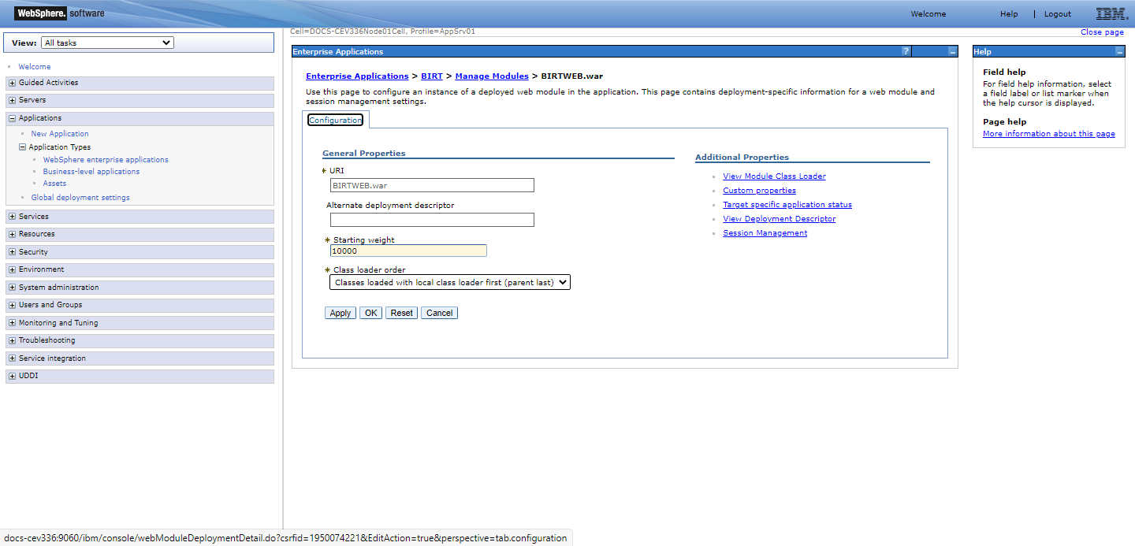

ii. For information on BIRT versions and settings for older versions of CE, refer to the earlier versions of this manual.

BIRT Logs

To configure the BIRT log, the following procedures must be performed:

1. In WebSphere:

a. If BIRT and CE are installed using the same EAR file, the relevant details

must be specified in the BIRTWEB.war configuration window.

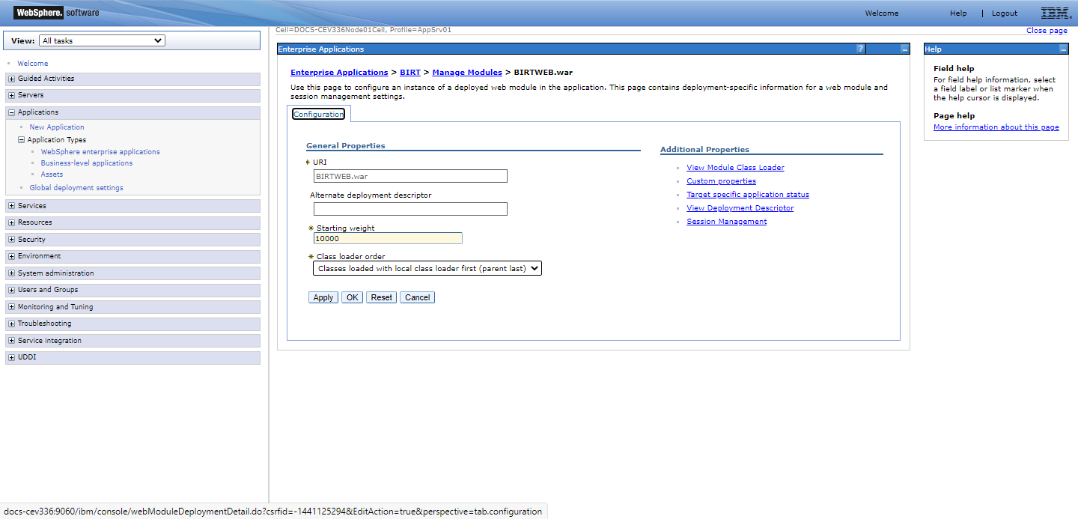

1. If BIRT and CE are installed using different EAR files, the following details must be specified in the Class loader configuration window:

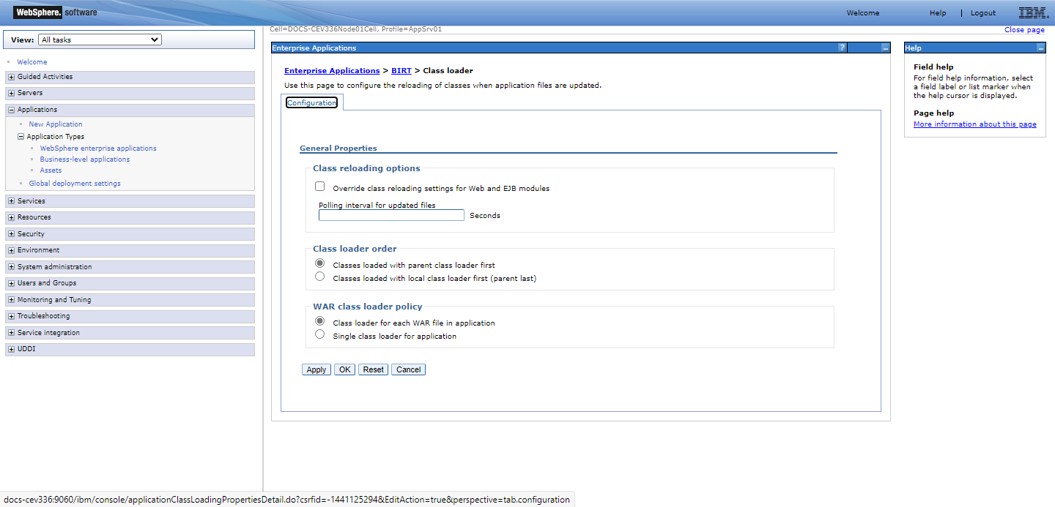

1. Locate the birt.properties file in the CE_SYS folder.

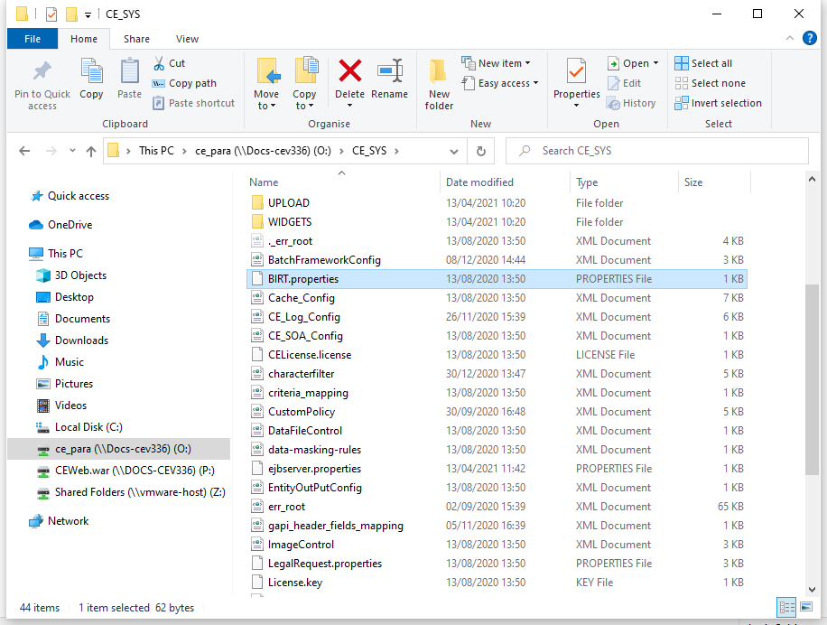

1. In the birt.properties file, configure the BIRT log details by specifying the BIRT_LOG_PATH (e.g. BIRT_LOG_PATH=C:\birtlog) and the BIRT_LOG_LEVEL.

The BIRT_LOG_LEVEL is used to define the log level which may be any of the following:

* Severe (highest value)
* Warning
* Info
* Config
* Fine
* Finer
* Finest (lowest value)
* All
* Off

The level OFF may be used to turn off logging, and the level ALL may be used to enable logging of all messages.

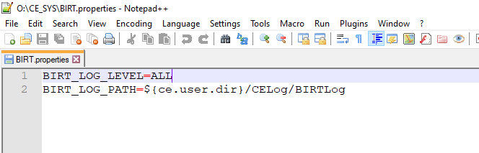

1. Confirm a transaction (e.g. Apply for Import LC) and click on the View button to view the generated form.

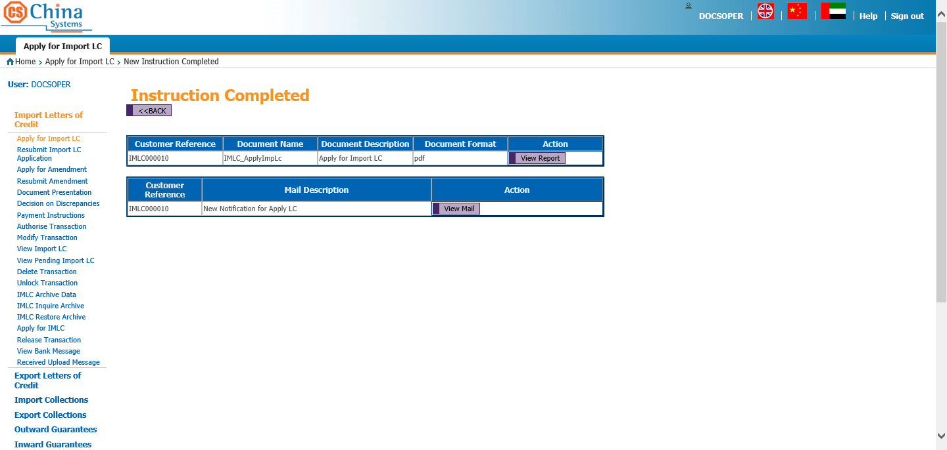

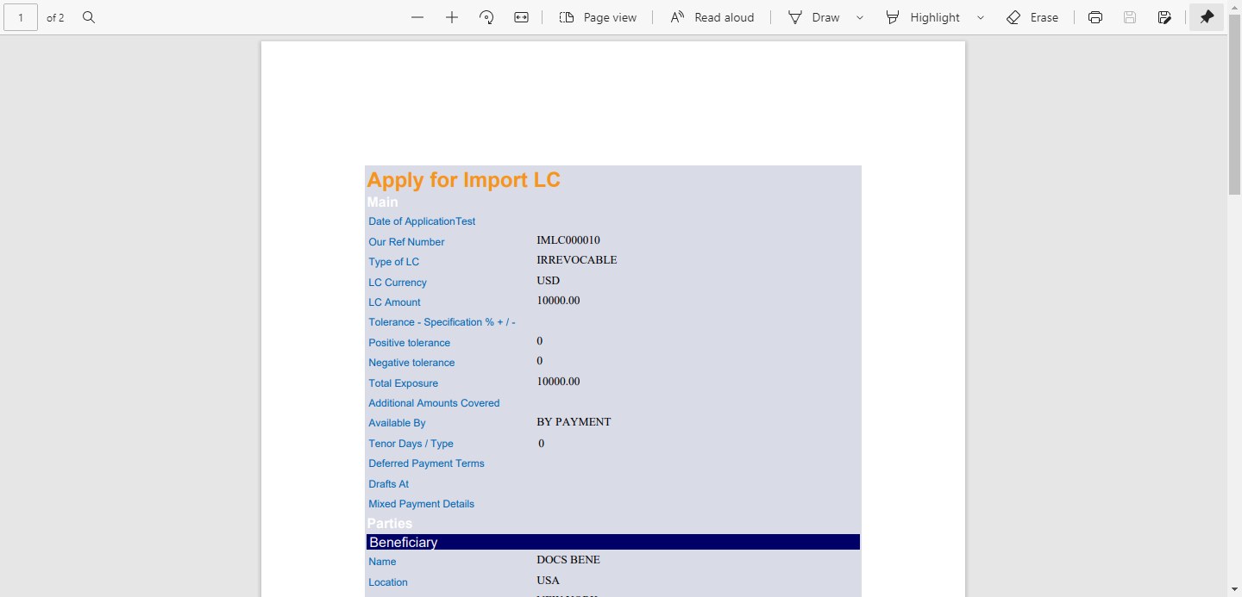

1. The BIRT log is generated in the path specified in the BIRT_LOG_PATH.

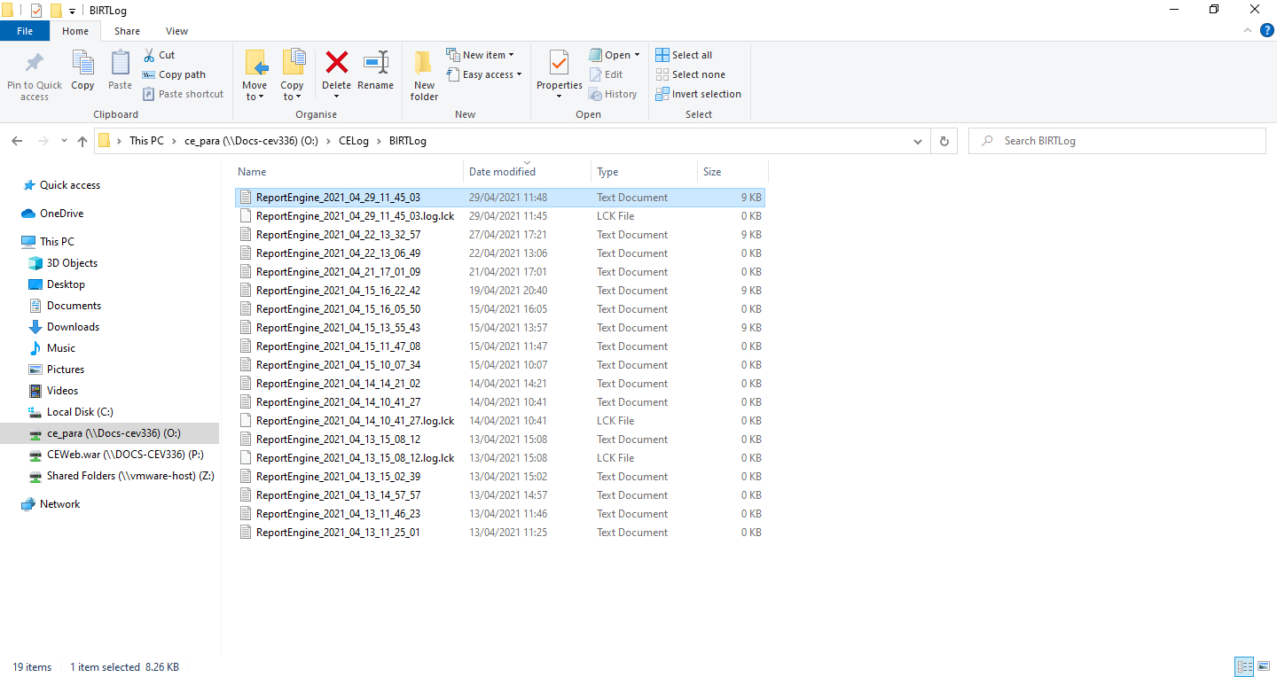

BIRT Deployment

The EAR file for the BIRT application can be deployed on either a separate port or together with the CE system in the same server, or on a different application server from CE.

The EAR file deployment and subsequent parameter checks are configured in WebSphere.

noteNOTE:

1. BIRT may also be deployed prior to the installation of the CE EAR file. However, installing the CE and BIRT applications in the same server is recommended.
2. For the steps demonstrated in this section, WAS Version 9.0.5.6 is used.

Deploying the BIRT EAR File

To successfully deploy the BIRT EAR file, the following WAS configurations must be defined.

|  |
| --- |
| Do the following . . . |

|  |  |  |
| --- | --- | --- |
| 1. Run the WebSphere Administrative Console. |  |  |
|  |  |  |
| 2. In the Applications menu, click on the New Application option. |  |  |
|  |  |  |
| 3. In the Install a New Application page, select the New Enterprise Application option. |  |  |
|  |  |  |
| 4. Select the Local file system option and then click on the Choose File button.  **NOTE:**  Button names may differ based on the browser used. |  |  |
|  |  |  |
| 5. Browse for the BIRT.ear file and click on the Open Button. |  |  |
|  |  |  |
| 6. The selected file is displayed in the New Application page.  Click on the Next button to continue to the next step of this procedure. |  |  |
|  |  |  |
| 7. The Select Installation Options page is displayed.  Select either option from the list:   * Fast Path – wherein the system prompts only when additional details are required; or * Detailed: wherein all installation options and parameters are displayed.   Click on the Next button to proceed.  **NOTE**:  The installation method used for this reference is Fast Path. |  |  |
|  |  |  |
| 8. The Installation Options page is displayed.  Accept the default settings and click on the Next button. |  |  |
|  |  |  |
| 9. The Map Modules to Servers page is displayed.  Accept the default settings, and click on the Next button. |  |  |
|  |  |  |
| 10. A summary of the selected options is displayed. Confirm that the Application Name displays BIRT.  Click on the Finish button. |  |  |
|  |  |  |
| 11. The installation process is started. |  |  |
|  |  |  |
| 12. At the end of the process, a corresponding message is displayed to indicate the status of the installation.  Click on the Save option. |  |  |

Configuring Other BIRT Settings

After the BIRT EAR file is deployed, certain parameter settings must be checked in WebSphere before the BIRT URL may be accessed to confirm a successful installation.

Parameter Check

To check BIRT-related parameters in WebSphere:

|  |
| --- |
| Do the following . . . |

|  |  |  |
| --- | --- | --- |
| 1. Run the WebSphere Administrative Console. |  |  |
|  |  |  |
| 2. In the Applications menu, click on the WebSphere Enterprise Applications option in the Application Types sub-menu. |  |  |
|  |  |  |
| 3. The index of installed applications is displayed.  Click on the link of the BIRT application. |  |  |
|  |  |  |
| 4. In the Configuration page, click on the Manage Modules option in the Modules section. |  |  |
|  |  |  |
| 5. The Manage Modules page is shown.  In the index of modules, click on the link for the BIRTWEB module. |  |  |
|  |  |  |
| 6. The BIRTWEB module configuration page is displayed.  From the Class Loader Order dropdown list, select this option:  Classes loaded with local class loader first (parent last)  Click on the OK button and then select the Save option to store the settings. |  |  |
|  |  |  |
| 7. Select the Save option to store the settings. |  |  |
|  |  |  |
| 8. In the Applications menu, click on the WebSphere Enterprise Applications option. |  |  |
|  |  |  |
| 9. In the index of applications in the Enterprise Applications page, select the BIRT application and click on the Start button. |  |  |
|  |  |  |
| 10. A message corresponding to the status of the start process is displayed.  Log off from the Administrative Console. |  |  |

BIRT URL

To access the BIRT URL:

1. Restart the WebSphere server.
2. To check the successful installation of BIRT, open the corresponding URL with the following format:  
     
   http://[Server IP Address]:[Port]/BIRTWEB/servlets/GetBirtData  
     
   **EXAMPLE:**  
     
   http://localhost:9080/BIRTWEB/servlets/GetBirtData   
     
     
     
   The port number can be checked by going to this path in the Websphere Administrative console:  
     
   Servers > Application Servers > [server] > Ports > WC_defaulthost

A message prompt to download the GetBirtData is displayed. This confirms that the successful deployment of BIRT.

|  |
| --- |
|  |

Figure 3. 1 BIRT Successfully Deployed Confirmation Message

Installing CE and BIRT on the Same Application Server

To install CE and BIRT in the same application server and using the same EAR file, the following procedures must be performed:

* Updating the CE EAR File
* Configuring WebSphere
* Updating the CE Core
* Binding the BIRT JDBC Reference
* Updating the Cache_Config.xml File
* Defining the Report System parameter
* Restarting CE

Updating the CE.EAR File

* Add the following statement to the CE.ear\META-INF\application.xml file:

(Start of code)

<module id="WebModule_1141991381002">  
 <web>  
 <web-uri>BIRTWEB.war</web-uri>  
 <context-root>BIRTWEB</context-root>  
 </web>  
</module>

(End of code)

|  |
| --- |
|  |

Figure 3. 2 Application.xml File

Configuring WebSphere

Run WebSphere –

* Deploy the CE.ear file and define the other required settings for installing the CE application.
* Access the Enterprise Applications option of the Applications Menu in Websphere. Click on the BIRT application. In the Modules section, select the Manage Modules option and then select the BIRTWEB module. In the BIRTWEB.war configuration window, set the Class loader order by selecting the option Classes loaded with local class loader first (parent last) from the dropdown list.

|  |
| --- |
|  |

Figure 3. 3 Class Loader Order: Classes Loaded with Local Class Loader First

Updating the CE Core

From the CE.ear, copy the Core.jar, CSBase.jar, and com.cs.core.xml.jar files into this path:

BIRTWEB.war\WEB-INF\lib

|  |
| --- |
|  |

Figure 3. 4 CSEECore.jar File

Binding the BIRT JDBC Reference

In order to set up the JDBC reference for the BIRT report, a new node must be added to the Web.xml file in BIRTWEB.war.

The following code shows the content of Web.xml with the added JDBC reference for BIRT:

|  |
| --- |
| (Start of code)  <?xml version="1.0" encoding="UTF-8"?>  <!DOCTYPE web-app PUBLIC "-//Sun Microsystems, Inc.//DTD Web Application 2.3//EN" "http://java.sun.com/dtd/web-app_2_3.dtd">  <web-app id="WebApp">  <display-name>BIRTWEB</display-name>  <listener>  <listener-class>com.cs.birt.listener.BirtWebListener</listener-class>  </listener>  <servlet>  <servlet-name>GetBirtData</servlet-name>  <display-name>GetBirtData</display-name>  <servlet-class>com.cs.birt.GetBirtData</servlet-class>  </servlet>  <servlet-mapping>  <servlet-name>GetBirtData</servlet-name>  <url-pattern>/servlets/GetBirtData</url-pattern>  </servlet-mapping>  <welcome-file-list>  <welcome-file>index.html</welcome-file>  <welcome-file>index.htm</welcome-file>  <welcome-file>index.jsp</welcome-file>  <welcome-file>default.html</welcome-file>  <welcome-file>default.htm</welcome-file>  <welcome-file>default.jsp</welcome-file>  </welcome-file-list>  <!—add jdbc reference to BIRT Start-->  <resource-ref id="ResourceRef_1217229454744">  <res-ref-name>jdbc/CET</res-ref-name>  <res-type>javax.sql.DataSource</res-type>  <res-auth>Container</res-auth>  <res-sharing-scope>Shareable</res-sharing-scope>  </resource-ref>  <!-- add jdbc reference to BIRT End-->  </web-app>  (End of code) |

|  |
| --- |
|  |

Figure 3. 5 Web.xml File

Updating the Cache_Config.xml File

Add the following parameter in the Cache_Config.xml file found in the CE_SYS folder:

<cache name="CACHE_RPTTEMP" maxElementsInMemory="500" eternal="true" timeToIdleSeconds="600" timeToLiveSeconds="600" overflowToDisk="false"/>

|  |
| --- |
|  |

Figure 3. 6 Cache_Config.xml File

Defining the Report System Parameter

Log on to the CE Utility as a Super Administrator user and add the BIRT_SERVER_URL system parameter in the System Parameters function. This is required for accessing the BIRT server.

|  |
| --- |
|  |

Figure 3. 7 System Parameters Function: Parameter Config Window

|  |  |  |
| --- | --- | --- |
| Field |  | Field Description |

|  |  |  |
| --- | --- | --- |
| **Parameter Name** |  | Specify this value: BIRT_SERVER_URL. |
|  |  |  |
| **Parameter Attribute** |  | Select the Common option from the dropdown list. |
|  |  |  |
| **Parameter Value** |  | Specify or browse for this path:  http://<local IP address>:<port number>/<context root name>/servlets/GetBirtData  **EXAMPLE:**  http://127.0.0.1:9080/BIRTWEB/servlets/GetBirtData  **NOTE:**  To enable generation of reports when HTTPS connection is used, use ‘https’ in the BIRT Server URL. |
|  |  |  |
| **CDATA** |  | If this flag is marked, all contents in the CDATA (Character Data) are treated as characters by the XML program. Special characters “]] and >” are not allowed.  Leave this flag unmarked.  **NOTE:**  If this flag is marked, the following details are included in the xml file that is generated:  <BIRT_SERVER_URL attr="C"> <![CDATA[http://localhost:9080/BIRTWEB/servlets/GetBirtData]]> </BIRT_SERVER_URL> |
|  |  |  |
| **Parameter Description** |  | Provide a short description of the parameter. |

Restarting CE

Restart the CE service in WAS to begin using the CE application.

|  |
| --- |
|  |

Figure 3. 8 Restarting the Application Server

NOTE: The CE Shared Libraries must not be referenced for BIRT.

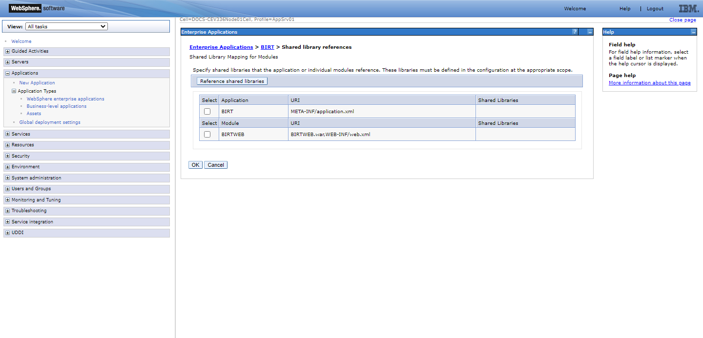

Installing CE on Separate Application Servers

To install CE and BIRT in separate application servers and using different EAR files, the following procedures must be performed:

* Installing the CE.EAR File
* Installing the BIRT.EAR File
* Including Additional Properties
* Updating the CE Core
* Updating the Cache_Config.xml File
* Defining the Report System Parameter
* Restarting CE

Installing the CE .EAR File

Run WebSphere to deploy the CE.ear file and define the other required settings for installing the CE application.

Installing the BIRT .EAR File

Run WebSphere and deploy the BIRT EAR file.

Including Additional Properties

The following parameters (ce.user.dir) are required if the BIRT EAR file is separately installed:

* CE_SYS\ CE_Log_Config.xml
* CE_SYS\ BIRT.properties – This is used to define the log level and path for BIRT 2.2.1 and above version. Below is a sample of the code:

BIRT_LOG_LEVEL=ALL

BIRT_LOG_PATH= ${ce.user.dir}/CELog/BIRTLog

BIRT_LOG_LEVEL: It is used to define log level. Log levels from lower to higher are: OFF, FINE, SEVERE, WARNING, INFO, CONFIG, FINER, FINEST and ALL.

BIRT_LOG_PATH: It is used to define log path. The backslash ‘\’ is not supported. It must be slash ‘/’.

* CE_SYS\ Cache_Config.xml
* CE_SYS\SYST\*.*
* REPORTTMPL\
* ReportEngine\

NOTE: In CE versions 3.3.1 and above, JVM variable is supported in BIRT log.

Updating the CE Core

From the CE.ear, copy the Core.jar, CSBase.jar, and com.cs.core.xml.jar files into this path:

BIRTWEB.war\WEB-INF\lib

Updating the Cache_Config.xml File

Add the following parameter in the Cache_Config.xml file found in the CE_SYS folder:

<cache name="CACHE_RPTTEMP" maxElementsInMemory="500" eternal="true" timeToIdleSeconds="600" timeToLiveSeconds="600" overflowToDisk="false"/>

Defining the Report System Parameter

Log on to the CE Utility as a Super Administrator user and add the BIRT_SERVER_URL system parameter in the System Parameters function. This is required for accessing the BIRT server.

|  |
| --- |
|  |

Figure 3. 9 BIRT_SERVER_URL System Parameter

|  |  |  |
| --- | --- | --- |
| Field |  | Field Description |

|  |  |  |
| --- | --- | --- |
| **Parameter Name** |  | Specify this value: BIRT_SERVER_URL. |
|  |  |  |
| **Parameter Attribute** |  | Select the Common option from the dropdown list. |
|  |  |  |
| **Parameter Value** |  | Specify or browse for this path:  http://<BIRT IP address>:<BIRT port number>/<context root name>/servlets/GetBirtData  **EXAMPLE:**  http://127.0.0.1:9080/BIRTWEB/servlets/GetBirtData  **NOTE:**  To enable generation of reports when HTTPS connection is used, use ‘https’ in the BIRT Server URL. |
|  |  |  |
| **CDATA** |  | If this flag is marked, all contents in the CDATA (Character Data) are treated as characters by the XML program. Special characters “]] and >” are not allowed.  Leave this flag unmarked.  **NOTE:**  If this flag is marked, the following details are included in the xml file that is generated:  <BIRT_SERVER_URL attr="C"> <![CDATA[http://localhost:9080/BIRTWEB/servlets/GetBirtData]]> </BIRT_SERVER_URL> |
|  |  |  |
| **Parameter Description** |  | Provide a short description of the parameter. |

Restarting CE

Restart the CE service in WAS to begin using the CE application.

|  |
| --- |
|  |

Figure 3. 10 Restarting the Application Server

BIRT Report Templates

A BIRT report template defines a basic report structure on which generated reports are based. It also contains defined data sets, which specify the data to display in a report. Creating the raw BIRT report templates, which are later used in setting up CE documents and reports, involves the following procedures:

* Creating the Report Template File
* Connecting to a Data Source
* Defining the Data Sets
* Designing the Report Template
* Using Data Set Fields in the Template Layout

Creating the Report Template File

Before designing the BIRT report template, the report project and template files must first be created.

|  |
| --- |
| Do the following . . . |

|  |  |  |
| --- | --- | --- |
| 1. Run the BIRT Report Designer application file: eclipse.exe. |  |  |
|  |  |  |
| The Eclipse application is initialized. |  |  |
|  |  |  |
| 2. The Workspace Launcher dialog box is displayed.  Select the workspace on which the files are to be stored and click on the OK button. |  |  |
|  |  |  |
| The Eclipse welcome window is displayed.  Close this window. |  |  |
|  |  |  |
| 3. Open the File Menu, select New, and click on the Project option. |  |  |
|  |  |  |
| 4. The New Project window is displayed.  Expand the Business Intelligence and Reporting Tools folder and select the Report Project option.  Click on the Next button. |  |  |
|  |  |  |
| 5. Specify a name for the report project.  To use the indicated Workspace location for storing report project, mark the Use default location option. Otherwise, use the Browse button to indicate the relevant directory.  Click on the Finish button. |  |  |
|  |  |  |
| 6. The Open Associated Perspective confirmation message is displayed.  Click on the Yes button. |  |  |
|  |  |  |
| 7. In the Report Design window, open the File menu, select New, and click on the Report option. |  |  |
|  |  |  |
| 8. The New Report window is displayed.  Select the previously defined project name; this functions as a parent folder for the report templates.  Specify the name of the report template to be created and click on the Next button. |  |  |
|  |  |  |
| 9. Select the report template to be used and click on the Finish button. |  |  |
|  |  |  |
| 10. The Report Design window is displayed. |  |  |

Connecting to a Data Source

A data source must be set up in order for the BIRT application to be able to access data that serves as the body (content) of the report.

A JDBC data source allows BIRT to access data from the database tables using SQL queries. This type of data source is used for producing list reports. To establish a connection to the database, the following settings must be defined when configuring a JDBC data source for a BIRT template.

Configuration

|  |
| --- |
|  |

Figure 3. 11 JDBC Data Source Configuration Window

|  |  |  |
| --- | --- | --- |
| Field |  | Field Description |

|  |  |  |
| --- | --- | --- |
| **Driver Class** |  | Select the relevant database driver from the dropdown list. |
|  |  |  |
| **Database URL** |  | Specify a value for the database URL. When using Oracle as database, the URL follows this format:  jdbc:oracle:thin:@[Server Name or IP Address]:1521:[DB Name]  **EXAMPLE:**  jdbc:oracle:thin:@DOCS-CEV330:1521:CEDB |
|  |  |  |
| **User Name** |  | Specify the username for accessing the database. |
|  |  |  |
| **Password** |  | Specify the password for the indicated user profile. |
|  |  |  |
| **JNDI URL** |  | Specify the URL of JNDI for database source access via Java EE api. |

Procedure

|  |
| --- |
| Do the following . . . |

|  |  |  |
| --- | --- | --- |
| 1. Make sure that the Data Explorer tab is displayed in the Report Design window. To access this tab, open the Window menu, select Show View, and click on the Data Explorer option. |  |  |
|  |  |  |
| 2. Right-click on the Data Source folder in the Data Explorer tab and click on the New Data Source option. |  |  |
|  |  |  |
| 3. The New Data Source window is displayed.  Mark this option: Create from a Data Source Type in the Following List  Select the JDBC Data Source item from the list and specify a name for the data source in the field provided.  Click on the Next button. |  |  |
|  |  |  |
| 4. The New JDBC Data Source Profile window is displayed.  Set the following values –   * Driver Class: This refers to the database driver used (e.g., oracle.jdbc.OracleDriver (v19.3)). * Database URL: Specify the database URL. * User Name: Specify the username for accessing the database. * Password: Specify the password for accessing the database. |  |  |
|  |  |  |
| **NOTE:**  If the relevant driver class is not included in the field dropdown list, click on the Manage Drivers button.  In the Manage JDBC Drivers window, click on the Add button. |  |  |
|  |  |  |
| Search for the relevant jdbc driver located in the Oracle Home directory. |  |  |
|  |  |  |
| The selected file is shown. Click on the OK button. |  |  |
|  |  |  |
| 5. To test for the database connection, click on the Test Connection button.  A confirmation message is displayed. Click on the OK button. |  |  |
|  |  |  |
| 6. The system returns to the New JDBC Data Source Profile window.  Click on the Finish button. |  |  |
|  |  |  |
| The defined data source is then listed under the Data Sources item in the Data Explorer tab. |  |  |

Defining the Data Sets

Specific details can be retrieved from the previously configured data source through the configuration of data sets.

|  |
| --- |
| Do the following . . . |

|  |  |  |
| --- | --- | --- |
| 1. Right-click on the Data Sets folder in the Data Explorer tab and click on the New Data Set option. |  |  |
|  |  |  |
| 2. The New Data Set window is displayed.  Set the following values –   * Data Set Name: Specify a name for the data set. This can be the name of a table from the data source. * Data Source: Select the previously defined data source. * Data Set Type: Choose SQL Select Query from the dropdown list.   Click on the Next button. |  |  |
|  |  |  |
| 3. The Query window is displayed.  The Available Items section lists all the schemas and tables from the previously selected data source. While this only lists a maximum of 100 tables per schema, an unlisted table can be specified through a query statement in the text area provided. |  | **NOTE:**  To list only the tables of a particular schema in the Available Items section, select it from the Schema dropdown list and click on the Apply Filter button. |
|  |  |  |
| Define a query statement in the given text area for selecting the fields to be used in the report template.  Initially, the value of the Where condition must be set to ‘?’ (i.e., not a fixed value). Its value is defined later in the process.  Click on the Finish button. |  |  |
|  |  |  |
| 4. The Edit Data Set window is displayed.  The Output Columns section lists all the fields selected from the defined query. Click on the OK button. |  |  |
|  |  |  |
| 5. Right-click on the Report Parameters folder in the Data Explorer tab and click on the New Parameter option. |  |  |
|  |  |  |
| 6. The New Parameter window is displayed.  Specify the name of the key field to be used as a key for the report template in the Name field (e.g. C_UNIT_CODE). This is also used for the previously selected data source.  Set its data type and click on the OK button. |  |  |
|  |  |  |
| 7. Double-click on the data set created (e.g., Data Set). |  |  |
|  |  |  |
| 8. The Edit Data Set window is displayed. |  |  |
|  |  |  |
| Select the Parameters option on the left pane to display the Parameters section.  Click on the New button. |  |  |
|  |  |  |
| 9. The New Parameter dialog box is displayed.  Set the following values –   * Name: Specify a name to reference the previously defined report parameter (key field). This parameter corresponds with the ‘?’ defined in the query. * Data Type (e.g., String) * Direction: Input * Default Value: N/A * Linked to Report Parameter: Select the previously defined report parameter (e.g., C_UNIT_CODE).   Click on the OK button. |  |  |
|  |  |  |
| 10. The system returns to the Edit Data Set window.  Define as many parameters as required. |  |  |

Designing the Report Template

To provide a professional and consistent design for generating reports, the report template layout must be constructed prior to the insertion of data elements into the template. Template layouts can range from skeletal outlines with predefined themes to complete reports.

The BIRT Designer carries different tools that may be used in carrying out a report design. These are:

* Layout Editor
* Palette View

Layout Editor

The Layout Editor allows the user to place different design elements in the template. It is used mainly to construct the report and acts as a canvass for positioning and formatting report elements.

|  |
| --- |
|  |

Figure 3. 12 Layout Editor

Within the Layout Editor, the following tabs may be used to come up with a design suitable for the relevant business requirements: Layout, Master Page, Script, XML Source, and Preview.

Layout Tab

This tab functions as a canvass and is used for the visual layout of the report. This supports drag-and-drop functionality wherein design elements from the palette may be dragged into the editor to build the required template layout.

|  |
| --- |
|  |

Figure 3. 13 Layout Tab

Master Page

This tab is used for setting the header, footer, and background image configurations that are to be applied to the entire report. This page is often the location of the corporate header.

|  |
| --- |
|  |

Figure 3. 14 Master Page

Script Tab

This tab allows access to the JavaScript Editor. This is used to code event scripts for report templates and is typically used to add criteria in retrieving data.

|  |
| --- |
|  |

Figure 3. 15 Script Tab

XML Source

This tab displays the XML source code for the report design. This is automatically updated whenever design elements are added, edited, or deleted.

|  |
| --- |
|  |

Figure 3. 16 XML Source tab

noteNOTE: Though it is possible to modify the XML within this tab, it is better to use the layout view.

Preview

This tab is used to preview the report output. This allows the report developer to quickly render a working report to HTML.

|  |
| --- |
|  |

Figure 3. 17 Preview Tab

noteNOTE: The Preview icon in the toolbar may also be used to view the reports in other supported formats.



Palette View

The Palette View contains the different design elements or report items that may be placed anywhere within the Layout page. It is also the main design layout tool for creating report templates.

The available design elements are Label, Text, Dynamic Text, Data, Image, Grid, List, Table, and Chart.

Label

This is used for adding a single line of static text. The text can be externalized for localization and supports such properties as font sizing, highlighting, and usage as a hyperlink.

To use this report element, select it from the palette and place it within the Layout page.

|  |
| --- |
|  |

Figure 3. 18 Label Design Element

Text

This is used to add a block of text. Though similar to Label, the Text may be in plain text or may display multi-line, highly formatted HTML. Values from existing data sets, parameters, JavaScript functions, and BIRT-specialized script functions may also be added into the formatted HTML using the BIRT Expression Builder.

This element can also be used to create scripts that are executed on the client side by using the tag. To use this report item, select it from the palette and place it within the Layout page. Use the Edit Text Item window to enter blocks of text using HTML codes.

|  |
| --- |
|  |

Figure 3. 19 Text Design Element

Dynamic text

This is used to insert a block of text with optional CLOB data expressions. These values can also be combined with additional data using the BIRT Expression Builder.

To use this design element, select it from the palette and place it within the Layout page. Use the Expression Builder window to mix a block of static text with an expression.

|  |
| --- |
|  |

Figure 3. 20 Dynamic Text Design Element

Data

This serves as the essential element for displaying values from data sources. Using the Expression Builder, data values may be altered and manipulated.

**EXAMPLE:**

If a data set contains separate columns with different values, the values may be integrated into one data element using the Expression Builder.

To use this report item, select it from the palette and place it within the Layout page

|  |
| --- |
|  |

Figure 3. 21 Data Design Element

Image

This is used to include pictures in the report output. These images may be retrieved from a URI or embedded in the design, and it may include dynamic images (BLOB) from a data source or image files in a resource folder.

To use this design element, select it from the palette and place it within the Layout page.

|  |
| --- |
|  |

Figure 3. 22 Image Design Element

Grid

This element acts as a container for other report elements and is used to position elements in a logical manner. Grid elements are configured in tabular format.

|  |
| --- |
|  |

Figure 3. 23 Grid Design Element

List

This acts as a container for other elements. Lists iterate over data sets that are bound to the list. The default list element has a header, footer, and detail section. The header and footer are usually displayed once, while the detail section is displayed for every row of the data set that is bound to the list. Within the detail section, a text element or another container element may be added such as a grid, table, or another list.

|  |
| --- |
|  |

Figure 3. 24 List Design Element

Table

Similar to List, the Table design element is also a container element that iterates over bound data sets; the data, however, are represented in tabular format. The table element layout is similar to an HTML table. Table elements contain header, footer and detail sections as well as columns.

|  |
| --- |
|  |

Figure 3. 25 Table Design Element

Chart

This inserts charts into the report template and chart values may be defined. The types of Chart are as follows:

* Bar Chart
* Line Chart
* Area Chart
* Pie Chart
* Meter Chart
* Scatter Chart
* Stock Chart

|  |
| --- |
|  |

Figure 3. 26 Chart Design Element

Using Data Set Fields in the Template Layout

Data from created data sets may be incorporated into the template. Specifically, a field can be included in the template by dragging the selected field from the data set list into the layout page.

noteNOTE: To include or delete fields within the data set, drag the data set into the template and individually delete the fields that are not to be included.

|  |
| --- |
|  |

Figure 3. 27 Using the Data Set Fields into the Template Layout

Producing CE Documents

OVERVIEW

Chapter Four

PARAMETER SETTINGS

Overview

A document generally refers to a report form that displays transaction details based on the defined Form and Report Template settings. It is generated during transaction processing but can be viewed after the transaction has been authorized.

The generated documents are stored in the defined Output directory. These can be generated in the following formats:

* PDF
* HTML

|  |  |
| --- | --- |
| TRANSACTION PROCESSING EXAMPLE  Create and confirm an LC application transaction. The defined document – IMLC_ApplyImpLc – is listed in the document list after the transaction has been authorised.   |  | | --- | |  |   Click on the corresponding View Report button to display the generated document in another window.    The generated report is saved in the Output directory. |

Parameter Settings

The actual BIRT template, defined through BIRT, must be associated with a CE form that is later attached to the transaction function. Generating documents such as purchase orders requires these settings in the CE Utility:

* Defining the output directory
* Configuring the CE report template
* Creating the document form
* Setting up the transaction function
* Setting up the product function
* Generating the XML files

Defining the Output Directory

The Output directory is the repository of all documents and reports generated through BIRT. This directory can be defined in the Application Server option of the WebSphere Administrative Console. In the Process Definition – Configuration screen, click on the Java Virtual Machine property. Click on the Custom Properties option and create the following setting:

|  |  |  |
| --- | --- | --- |
| Field |  | Field Description |

|  |  |  |  |
| --- | --- | --- | --- |
| **Name** |  | Specify the name of the output directory: ce.output.dir. | |
|  |  |  | |
| **Value** |  | Specify the directory for the output.  **EXAMPLE:**  C:\OUTPUT | |
|  |  |  | |
| **Description** |  | Provide a description for this new property.  **EXAMPLE:**  output directory | |
|  | | | |

|  |
| --- |
|  |

Figure 4. 1 General Properties Configuration for the Output Directory

NOTE: The output folder must already exist; otherwise, the output data is not generated.

If this property is not defined, the system generates the output data in the default directory, which is the TRXDATA folder of the parameter directory (as defined in ce.user.dir).

Configuring the CE Report Template

The report template and its parameters that are set up in BIRT must be imported to the CE Utility for parameter setting.

Configuration

Report templates are defined for the different CE modules to correspond to specific report engines such as BIRT.

The Report Template function is used to configure these report templates as well as import these to the relevant data source. There are four tabs provided in the Report Template function window: Create Report, Document, Security Report, and Transaction Report.

|  |
| --- |
|  |

Figure 4. 2 Report Template Function – Create Report tab

Creating the Report Template

In configuring a report template, the following details must be defined in the Manual Input tab of the Report Template Input window.

|  |
| --- |
|  |

Figure 4. 3 Report Template Input Window – Manual Input tab

|  |  |  |
| --- | --- | --- |
| Field |  | Field Description |

|  |  |  |
| --- | --- | --- |
|  |  | ***General Information*** |
|  |  |  |
| **Report Name** |  | Specify the name for the report template. This must be the same as the name of the report template created in BIRT. |
|  |  |  |
| **Report Description** |  | Provide a description of the report template. |
|  |  |  |
| **Report Folder** |  | **NOTE:**   1. This setting pertains to Crystal reports only. It is used to define the folder on which the report template is stored in the crystal server. Refer to the succeeding Crystal Report Folder discussion for more details. 2. CE version 3.3.6 supports Crystal versions RAS10 and RAS11 |
|  |  |  |
|  |  | ***Report Parameters*** |
|  |  |  |
| **Parameter Name** |  | This field refers to the name of the parameter being added. To add a parameter, click on the Add button in this section. A row is displayed, in which a new parameter name can be specified; this parameter must already exist in the actual BIRT template created. Select a parameter type from the Parameter Type dropdown list (e.g., String). Click on the Save button to continue.  As many parameters can be added as required. These parameters serve as the link between the BIRT report template and this current report template being defined in CE. |
|  |  |  |
| **Parameter Type** |  | Select the type of the corresponding parameter from the dropdown list. |

noteNOTE: The Template Import tab of the Report Template window is *currently not used.*

|  |
| --- |
| Crystal Report Folder  To define the report folder for Crystal reports:   1. Logon the CE Utility as a super administrator user and configure the required parameters in the System Parameters function.      1. Access the Crystal Enterprise Admin Launchpad and click on the Crystal Management Console link.      1. Logon the Crystal Management Console using the following default credentials:  * User Name: administrator * Password: [no password]      1. The Crystam Management Console homepage is shown. Click on the Folders link.      1. Click on the corresponding Reports folder. To create a new folder, click on the New Folder button.      1. In the Objects tab, add the corresponding template.      1. In the CE Utility, specify the name of the folder on which the report template is stored. |

Importing the Report Template to the Transaction Data Source

The created report template can only be made available for use in the CE modules when it is imported to the transaction data source. When the created report template is for a document form, this is configured through the Document tab of the Report Template function window.

|  |
| --- |
|  |

Figure 4. 4 Report Template Function – Document tab

Procedure

To configure the report template:

|  |
| --- |
| Do the following . . . |

|  |  |  |
| --- | --- | --- |
| 1. Click on the Report Template function from the Transaction Function group. |  |  |
|  |  |  |
| 2. In the Create Report tab of the Report Template window, select the relevant data source and report engine from their respective dropdown lists. |  |  |
|  |  |  |
| 3. Click on the Add button on the toolbar.  Alternatively, right-click on the configuration section and select the Add option from the dropdown list that is displayed. |  |  |
|  |  |  |
| 4. The Report Template Input window is displayed.  Configure the required settings in the Manual Input tab, and click on the Save button. |  |  |
|  |  |  |
| 5. The report name is listed in the top section of the Report Template window, while the lower grid lists the parameter/s added. |  |  |
|  |  |  |
| 6. In the Document tab of the Report Template window, select the data source to which the report template is to be imported, and click on the Import button. |  |  |
|  |  |  |
| 7. In the window that is displayed, select the previously created report template, and mark the corresponding Isimport flag.  Click on the Save button to continue. |  |  |
|  |  |  |
| 8. The newly imported report template is displayed in the grid of the Document tab. |  |  |

Creating the Document Form

Document forms are created through the Form function of the CE Utility.

Configuration

Configuring the document form involves defining the Form rule and mapping the table fields and the report parameters.

|  |
| --- |
|  |

Figure 4. 5 Form Function – Form Set tab

noteNOTE: For additional details on the Form function, refer to the *CE Utility Reference: Transaction Functions* manual*.*

Form Rule Configuration: Basic Information

To configure the document form, the Form Rule must be defined through the Config Form Set window of the CE Utility. The following details are required:

|  |
| --- |
|  |

Figure 4. 6 Config Form Set window

|  |  |  |
| --- | --- | --- |
| Field |  | Field Description |

|  |  |  |
| --- | --- | --- |
| **Form Generate Type** |  | This refers to the type of form to be created. The available options in the dropdown list are:   * Report – The form is generated as a document in a format that is supported by the BIRT tool. * Html – The form is generated as a document in HTML format.   Select the Report type. |
|  |  |  |
| **Form Set Name** |  | As the type of form being defined is Report, this field is disabled and defaults to the name of the selected report template (see Form Template File field). |
|  |  |  |
| **Form Set Desc** |  | As the type of form being defined is Report, this field is disabled and defaults to the description of the selected report template (see Form Template File field). |
|  |  |  |
| **Form template file** |  | As the Form Generate Type option selected is Report, this field is enabled.  Click on the corresponding browse button. In the Get Report Name dialog box that is displayed, select the report template to be used and click on the Save button. |
|  |  |  |
| **Html Header** |  | As the type of form being defined is Report, this field is disabled. |
|  |  |  |
| **Html Foot** |  | As the type of form being defined is Report, this field is disabled. |
|  |  |  |
| **Batch Process** |  | This is *currently* *not used*. |
|  |  |  |
|  |  | ***Printer Setting*** |
|  |  |  |
| **Printer Setting Flag** |  | This is *currently* *not used*. |
|  |  |  |
| **Printing Rows per Page** |  | This is *currently* *not used*. |
|  |  |  |
| **Release Printer** |  | This is *currently* *not used*. |
|  |  |  |
| **Pending Printer** |  | This is *currently* *not used*. |
|  |  |  |
|  |  | ***Mail/Fax Setting*** |
|  |  |  |
| **Mail Name** |  | If the form is to be sent as an e-mail upon transaction confirmation, select the relevant mail rule from the dropdown list. Mail rules or mail details settings are defined in the Output Device function of the System Function group. |
|  |  |  |
| **Fax Name** |  | This is *currently not used.* |

Form Rule Configuration: Mapping Information

The configuration of the field-mapping relationship between the table fields and parameters is defined in the Document Field tab of the Form function window.

|  |
| --- |
|  |

Figure 4. 7 Form Function – Document Field tab

Specifying the Field Set Name, Field Set Type, and Table

The following details must be defined in the Config Document Field – Step 1 window.

|  |
| --- |
|  |

Figure 4. 8 Config Document Field – Step 1 window

|  |  |  |
| --- | --- | --- |
| Field |  | Field Description |

|  |  |  |
| --- | --- | --- |
| **Form Set Name** |  | This defaults to the name of the newly created form set. |
|  |  |  |
| **Fields Set Name** |  | Specify a name for the set of fields to be mapped. This is usually the same as the indicated Form Set Name value. |
|  |  |  |
| **Field Set Type** |  | This refers to the type of the target fields. As the type of form being defined is Report (i.e., the Form Generate Type option selected in the Config Form Set window is Report), the Report option is automatically marked. |
|  |  |  |
| **Table Name** |  | This field refers to the name of the table which fields are to be mapped to the report fields. |

Selecting the Value Type and Field Value Template

The following details must be defined in the Config Document Field – Step 2 window.

|  |
| --- |
|  |

Figure 4. 9 Config Document Field – Step 2 window

|  |  |  |
| --- | --- | --- |
| Column |  | Description |

|  |  |  |
| --- | --- | --- |
| **Key Field** |  | This column displays the Key fields of the table to which the form fields are to be mapped. Select the key field of the defined source table (e.g., _SYS_COMPANY_CODE). |
|  |  |  |
| **Value Type** |  | As the mapping rule is being defined for a Report form, select Report from the dropdown list. |
|  |  |  |
| **Field Value** |  | This column displays the parameters defined for the selected report template. Select the report parameter that is to be mapped to the key field. This ensures that the report parameter is linked to the system. |

noteNOTE:

1. The recommended mapping conditions are as follows –

FIELD NAME MAPPING

C_UNIT_CODE _SYS_COMPANY_CODE  
 C_MAIN_REF C_MAIN_REF (screen field)  
 I_EVENT_TIMES _SYS_EVENT_TIME

1. The following table lists the available system parameters that can be mapped to the report template.

|  |  |  |
| --- | --- | --- |
| System Parameter |  | Description |

|  |  |  |
| --- | --- | --- |
| **_SYS_BANK_GROUP** |  | This refers to the bank group Id. |
|  |  |  |
| **_SYS_COUNTRY_CODE** |  | This refers to the country code. |
|  |  |  |
| **_SYS_COMPANY_GROUP** |  | This refers to the company group. |
|  |  |  |
| **_SYS_COMPANY_CODE** |  | This refers to the company code. |
|  |  |  |
| **_SYS_USER_ID** |  | This refers to the user Id. |
|  |  |  |
| **_SYS_PRODUCT_ID** |  | This refers to the product Id. |
|  |  |  |
| **_SYS_FUNC_ID** |  | This refers to the function Id. |
|  |  |  |
| **_SYS_DATE** |  | This refers to the system date, the format of which is: YYYY-MM-DD. |
|  |  |  |
| **_SYS_TIME** |  | This refers to the system time, the format of which is: hh:mm:ss. |
|  |  |  |
| **_SYS_DATETIME** |  | This refers to the system date and time, the format of which is: YYYY-MM-DD hh:mm:ss. |
|  |  |  |
| **_SYS_EVENT_TIME** |  | This refers to the current event time. The value can either be:   * 1 – for the new master record * Current event number – for the EC function * Max (I_EVENT_TIME) + 1 – for Edit Master |

Procedure

To configure the form rule:

|  |
| --- |
| Do the following . . . |

|  |  |  |
| --- | --- | --- |
| 1. Run the Form function from the Transaction Function group of the CE Utility. |  |  |
|  |  |  |
| 2. The Form function window is displayed. Two tabs are shown:   * Form Set * Sharable   In the Form Set tab, select the relevant module and click on the Add button on the toolbar. |  |  |
|  |  |  |
| 3. The Config Form Set window is displayed.  Define the required settings and click on the Save button. |  |  |
|  |  |  |
| 4. The details of the defined Form set are shown in the grid.  To set the field-mapping relationship between the table fields and report parameters, select the newly created Form rule and go to the Document Field tab. |  |  |
|  |  |  |
| In the Document Field tab, click on the Add button on the toolbar. |  |  |
|  |  |  |
| In the Config Document Field – Step 1 window that is displayed, define the form set name, field set type and source table.  Click on the Next button. |  |  |
|  |  |  |
| Define the key field mapping settings in the Config Document Field – Step 2 window that is displayed.  Click on the Save button. |  |  |
|  |  |  |
| The newly defined mapping rule is shown in the grid under the Document Field tab of the Form function window.  When selected, the details are shown below the mapping rule name. |  |  |
|  |  |  |
| **XML GENERATION:**  Run the XML Generation function and generate the XML files for the Form Set parameter. |  |  |
|  |  |  |
| The XML files are generated in this path:  [PARAMETER DRIVE]\[BANK]\[COUNTRY]\AP\FORM |  |  |

Setting up the Transaction Function

A transaction function with specific Form-related settings must be created for generating the document form.

noteNOTE: The DV.appendForm (String formName) is used to generate forms in both HTML and PDF format.

|  |
| --- |
| Do the following . . . |

|  |  |  |
| --- | --- | --- |
| 1. Attach the newly-created form to the relevant transaction function by using the Form component and DV.appendForm method.  **EXAMPLE:**  DV.appendForm(“IMLC_ApplyLC”); |  |  |
|  |  |  |
| 2. Add the Trx Generate Document attribute to the transaction function. |  |  |

Setting up the Product Function

A product function is the counterpart of transaction function in browser processing. Although it is the transaction function that executes parameter rules and operations, it is the product function that the end-user accesses at runtime. A product function must be associated to a transaction function, a product and a product group. This is done through the functions in the Product Functions group of the CE Utility.

noteNOTE: Refer to the *CE Building a Product* manual for more details regarding the Product Function.

Create a New Product

To be able to generate reports, the product function must be created according to the business requirements.

|  |
| --- |
| Do the Following . . . |

|  |  |  |
| --- | --- | --- |
| 1. Run the Product Function Setting function from the Product Function group of the CE Utility. |  |  |
|  |  |  |
| 2. From the Products tab of the Product Function Setting window, click on the Add button on the toolbar. |  |  |
|  |  |  |
| 3. The Products Setting dialog box is displayed. Specify the relevant details, and click on the Save button. |  |  |
|  |  |  |
| 4. The setting is then displayed in the products directory. |  |  |

Assign the Product Group and Function of a Product

When the Product function has been created, it has to be assigned to a product that belongs to a Transaction-, Security- or Reference-type product group.

|  |
| --- |
| Do the Following… |

|  |  |  |
| --- | --- | --- |
| 1. In the Product Function tab of the Product Function Setting window, select the product group from the left pane.  Click on the Edit button on the toolbar. |  |  |
|  |  |  |
| 2. The Set Products dialog box is displayed.  All available products are listed, that is, those that have not been assigned to other product groups. Products that have already been selected are those that already belong to the current product group.  Mark the newly created product to be assigned to the selected product group, and click on the Save button. |  |  |
|  |  |  |
| 3. Select the added product in the product group on the left pane.  Click on the Add button on the toolbar. |  |  |
|  |  |  |
| 4. The Product Function Config dialog box is displayed.  Specify the relevant details, and click on the Save button when done. |  |  |

Generating the XML Files

After configuring the required parameters of the document form (i.e., Report Template, Form Set, Attribute, Transaction Function and Product Function Settings), the XML files must be generated through the XML Generator function in the Maintenance function group.

|  |
| --- |
| Do the following . . . |

|  |  |  |
| --- | --- | --- |
| 1. Run the XML Generator function in the Maintenance function group. |  |  |
|  |  |  |
| 2. In the AP Server tab, double-click on the Form set parameter to generate the XML files. |  |  |
|  |  |  |
| The XML files for the Form Set parameter is generated on the following path:   * Parameter Drive:\[Bank group]\[Country Code]\AP\FORM |  |  |
|  |  |  |
| 3. In the AP Server tab, double-click on the Report Template parameter to generate the XML files. |  |  |
|  |  |  |
| The XML files for the Report Template is generated on the following path:   * Parameter Drive:\[Bank group]\[Country Code]\AP\REPORT |  |  |
|  |  |  |
| 4. In the Web Server tab, double-click on the Function parameter and select the Attribute and Function options to generate the XML files. |  |  |
|  |  |  |
| The XML files for Attribute is generated on the following path:   * Parameter Drive:\[Bank group]\[Country Code]\AP\FUNCATTR |  |  |
|  |  |  |
| The XML file for the Transaction function parameter is generated on the following paths:   * Parameter Drive:\[Bank group]\[Country Code]\AP\FUNC * Parameter Drive:\[Bank group]\[Country Code]\WEB\FUNC |  |  |
|  |  |  |
| 5. In the Web Server tab, double-click on the Product Function Setting parameter to generate the XML file. |  |  |
|  |  |  |
| The generated pdt_[PRODUCT ID].xml file is saved in the following paths:   * [Parameter drive]:\ [Bank Group]\[Country Code]\WEB\PRODUCT * [Parameter drive]:\ [Bank Group]\[Country Code]\AP\PRODUCT |  |  |

Producing CE Transaction Reports

OVERVIEW

Chapter Five

PARAMETER SETTINGS

Overview

Transaction reports generally refer to a set or batch of summarized data. Through CE’s integration with the BIRT report engine, a standalone report function for generating transaction reports can be created; this provides real-time data queries for business research and analysis. This report can also be set up to allow the end-user to specify the parameters by which the report is generated.

The BIRT template, on which the CE online transaction report is to be based, must already be designed and reside in the relevant CE directory of the application server.

|  |  |
| --- | --- |
| Transaction Processing Example  Run the Report function. The Report Template lists all defined transaction report templates such as Consolidated Report.   |  | | --- | |  |   Click on the Confirm button to display the generated transaction report in another window. |

Parameter Settings

Generating transaction reports such as monthly summaries and statistics reports requires these settings in the CE Utility:

* Configuring the CE report template
* Setting up the transaction function
* Setting up the product function
* Generating the XML files

Configuring the CE Report Template

The report template and its parameters that have been set up in BIRT must be imported to CE Utility for parameter setting.

Configuration

Report templates are defined for the different CE modules to correspond to specific report engines such as BIRT. A report may be in PDF format.

The Report Template function is used to configure these report templates as well as import these to the relevant data source. There are four tabs provided in the Report Template function window: Create Report, Document, Security Report, and Transaction Report.

|  |
| --- |
|  |

Figure 5. 1 Report Template Function – Create Report tab

Creating the Report Template

When a report template is being configured, the following template details must be defined in the Manual Input tab of the Report Template Input window.

|  |
| --- |
|  |

Figure 5. 2 Report Template Input Window – Manual Input tab

|  |  |  |
| --- | --- | --- |
| Field |  | Field Description |

|  |  |  |
| --- | --- | --- |
|  |  | ***General Information*** |
|  |  |  |
| **Report Name** |  | Specify the name for the report template. Make sure that it is the same as the name of the report template created in BIRT. |
|  |  |  |
| **Report Description** |  | Provide a description of the report template. |
|  |  |  |
| **Report Folder** |  | **NOTE:**   1. This setting pertains to Crystal reports only. It is used to define the folder on which the report template is stored in the crystal server. Refer to the preceding Crystal Report Folder discussion for more details. 2. CE version 3.3.6 supports Crystal versions RAS10 and RAS11 |
|  |  |  |
|  |  | ***Report Parameters*** |
|  |  |  |
| **Parameter Name** |  | This field refers to the name of the parameter being added. To add a parameter, click on the Add button in this section. A row is displayed, in which a new parameter name can be specified; this parameter must already exist in the actual BIRT template created. Select a parameter type from the Parameter Type dropdown list (e.g., String). Click on the Save button to continue.  As many parameters can be added as required. These parameters serve as the link between the BIRT report template and this current report template being defined in CE. |
|  |  |  |
| **Parameter Type** |  | Select the type of the corresponding parameter from the dropdown list. |

noteNOTE: The Template Import tab of the Report Template window is *currently not used.*

Importing the Report Template to the Transaction Data Source

The created report template can only be made available for use in the CE modules when it is imported to the transaction data source. When the created report template is for a transaction report, this is configured through the Transaction Report tab of the Report Template function window.

|  |
| --- |
|  |

Figure 5. 3 Report Template Function – Transaction Report Tab

Mapping the Parameters to the JSP Fields

The parameters defined in the template for a transaction report must be mapped to the fields in the JSP file of the transaction function that is to generate the transaction report.

The fields required in the mapping rule depend on the parameters set in the report template. These fields and the following are defined in the Mapping Field window:

* **JSP File Name -** Specify or browse for the JSP file which fields are to be mapped with the report template parameters.

|  |
| --- |
|  |

Figure 5. 4 Mapping Field Window

Procedure

To configure the report template:

|  |
| --- |
| Do the following . . . |

|  |  |  |
| --- | --- | --- |
| 1. Run the Report Template function from the Transaction Function group. |  |  |
|  |  |  |
| 2. In the Create Report tab of the Report Template window, select the relevant data source and report engine from their respective dropdown lists. |  |  |
|  |  |  |
| 3. Click on the Add button on the toolbar. |  |  |
|  |  |  |
| 4. The Report Template Input window is displayed.  Configure the required settings in the Manual Input tab, and click on the Save button. |  |  |
|  |  |  |
| 5. The report name is listed in the top section of the Report Template window, while the lower grid lists the parameter(s) added. |  |  |
|  |  |  |
| 6. In the Transaction Report tab of the Report Template window, select the data source to which the report template is to be imported, and click on the Import button. |  |  |
|  |  |  |
| 7. In the window that is displayed, select the report template that has been previously created, and mark the corresponding Isimport flag.  Click on the Save button to continue. |  |  |
|  |  |  |
| 8. The newly-imported report template is displayed in the grid of the Transaction Report tab. |  |  |
|  |  |  |
| 9. To select the JSP file and map the parameters to the fields in the JSP file, select the setting from the grid in the upper panel and right-click to select the Edit button from the popup menu that is displayed. |  |  |
|  |  |  |
| 10. The Mapping Field window is displayed.  Define the required settings, and click on the Save button. |  |  |

Setting up the Transaction Function

A transaction function with specific Screen-related settings must be created for generating the transaction report.

Function Information

Create the relevant transaction function according to the business requirements.

|  |
| --- |
|  |

Figure 5. 5 Function Add Window

noteNOTE: The attached Main Program does not have any effect on the report processing.

Screen Settings

Apart from attaching the relevant JSP file and template to the transaction function, create the following settings.

noteNOTE: The Main Screen must always be set to the screen selected from the Mapping Field window of the Report Template function.

|  |
| --- |
|  |

Figure 5. 6 Transaction Function – Transaction Component Config Tab

Ensure that the JSP file to be attached to the transaction function contains the following system fields:

|  |  |  |
| --- | --- | --- |
| System Field |  | Field Description |

|  |  |  |
| --- | --- | --- |
| **C_REPORT_FORMAT** |  | This system field refers to the type(s) of format available for the report.  **EXAMPLE:**  <input type="hidden" name="C_REPORT_FORMAT" value = "pdf">  If more than one format is available, the field parameter must be set accordingly. For instance, the Interpreter field must be set in order to generate the available formats.  **EXAMPLE:**  <td class="FldLabel">Report Type</td>z  <td><select name="C_REPORT_FORMAT" class="CHAR_M" id="C_REPORT_FORMAT" title="Report Format">  <option value="pdf" selected>PDF</option>  <option value="excel">Excel</option>  </select>  </td>  **NOTE:**  The supported report output formats are dependent on the version of BIRT being used. Refer to the BIRT Versions section in Chapter Three of this manual for details. |
|  |  |  |
| **C_REPORT_TNAME** |  | This field refers to the name of the report template in BIRT.  **EXAMPLE:**  <td><select name="C_REPORT_TNAME" class="CHAR_O" id="select" title="Report Template">  <option value="ConsolidatedReport" selected>Consolidated Report</option>  </select>  If more than one report template is available, the field parameter must be set accordingly. For instance, the Interpreter field must be set in order to generate the available report templates. |

Setting up the Product Function

A product function is the counterpart of transaction function in browser processing. Although it is the transaction function that executes parameter rules and operations, it is the product function that the end-user accesses at runtime. A product function must be associated to a transaction function, a product and a product group. This is done through the functions in the Product Functions group in CE Utility.

noteNOTE: Refer to the *CE Building a Product* manual for more details regarding the Product Function.

Create a New Product

To be able to generate reports, the product function must be created according to the business requirements.

|  |
| --- |
| Do the following … |

|  |  |  |
| --- | --- | --- |
| 1. Run the Product Function Setting function from the Product Function group of the CE Utility. |  |  |
|  |  |  |
| 2. From the Products tab of the Product Function Setting window, click on the Add button on the toolbar. |  |  |
|  |  |  |
| 3. The Products Setting dialog box is displayed. Specify the relevant details, and click on the Save button. |  |  |
|  |  |  |
| 4. The setting is then displayed in the products directory. |  |  |

Assign the Product Group and Function of a Product

When the Product function has been created, it has to be assigned to a product that belongs to a Transaction-, Security- or Reference-type product group

|  |
| --- |
| Do the Following… |

|  |  |  |
| --- | --- | --- |
| 1. Under the Product Function tab in the Product Function Setting window, select the product group from the left pane.  Click on the Edit button on the toolbar. |  |  |
|  |  |  |
| 2. The Set Products dialog box is displayed.  All available products are listed, that is, those that have not been assigned to other product groups. Products that have already been selected are those that already belong to the current product group.  Mark the newly created product to be assigned to the selected product group, and click on the Save button. |  |  |
|  |  |  |
| 3. Select the added product under the product group on the left pane.  Click on the Add button on the toolbar. |  |  |
|  |  |  |
| 4. The Product Function Config dialog box is displayed.  Specify the relevant details, and click on the Save button when done. |  |  |

Generating the XML Files

After configuring the required parameters of the Report, (i.e., Report Template, Screen, Transaction Function and Product Function Setting), the XML files must be generated through the XML Generator function of the Maintenance function group.

|  |
| --- |
| Do the following . . . |

|  |  |  |
| --- | --- | --- |
| 1. Run the XML Generator function of the Maintenance function group. |  |  |
|  |  |  |
| 2. In the AP Server tab, double-click n the Report Template parameter to generate the XML files. |  |  |
|  |  |  |
| The XML files for the Report Template is generated on the following path:   * Parameter Drive:\[Bank group]\[Country Code]\AP\REPORT |  |  |
|  |  |  |
| 3. In the Web Server tab, double-click on the Function parameter and select the created function to generate the XML files. |  |  |
|  |  |  |
| The XML file for the Transaction function parameter is generated on the following paths:   * Parameter Drive:\[Bank group]\[Country Code]\AP\FUNC * Parameter Drive:\[Bank group]\[Country Code]\WEB\FUNC |  |  |
|  |  |  |
| 4. To generate the XML file for Screen, double-click on the Screen parameter in the Web Server tab of the XML generator function. |  |  |
|  |  |  |
| The XML file for the Screen parameter is generated on the following path:   * Parameter Drive:\[Bank group]\[Country Code]\WEB\SCRN |  |  |
|  |  |  |
| 5. In the Web Server tab, double-click on the Product Function Setting parameter to generate the XML file. |  |  |
|  |  |  |
| The generated pdt_[PRODUCT ID].xml file is saved on the following paths:   * [Parameter drive]:\ [Bank Group]\[Country Code]\WEB\PRODUCT * [Parameter drive]:\ [Bank Group]\[Country Code]\AP\PRODUCT |  |  |

Special Report Functionalities

Using Different E-mail, Catalog Export, and Report Templates Per Entity

Chapter Six

Using Different E-mail, Catalog Export, and Report Templates Per Entity

Regions typically use common e-mail templates, Export catalog templates, and report templates. Nonetheless, such templates can be configured specifically for an entity (i.e., regional country code) according to its requirements.

Configuration

To enable the use of specific e-mail template, catalog export, and report templates per entity, the following xml files must be manually configured:

* EntityOutPutConfig.xml
* sys_extend_session_fields.xml

EntityOutPutConfig.xml

The bank or region options to be used for templates must be manually defined in the EntityOutPutConfig.xml file. This file is stored on the following path:

[Parameter Folder]\CE_SYS

If the parameters are not defined in this file, or if this file does not exist, the system applies the standard logic of using a common template for e-mails, catalog exports and reports.

|  |
| --- |
|  |

EntityOutPutConfig.xml File Sample Content:

|  |
| --- |
| <OUTPUT>  <MAILTEMPLATE BYBANK="Y/N" BYREGION="Y/N">  <TEMPLNAME BYBANK="N" BYREGION="Y">Create User Information</TEMPLNAME>  <TEMPLNAME BYBANK="N" BYREGION="Y">Apply for Import LC</TEMPLNAME>  </MAILTEMPLATE>  <CATALOGEXPORT BYBANK="Y/N" BYREGION="Y/N">  <PDF BYBANK="N" BYREGION="Y"></PDF>  <EXCEL BYBANK="N" BYREGION="Y"></EXCEL>  <HTML BYBANK="N" BYREGION="Y"></HTML>  </CATALOGEXPORT>  <BIRTREPORT BYBANK="Y/N" BYREGION="Y/N">  <TEMPLATENAME BYBANK="N" BYREGION="Y">IMLC_ApplyImpLc</TEMPLATENAME>  </BIRTREPORT>  </OUTPUT> |

NOTE: Map the mail and report templates.

Example:

[Parameter Folder]\CSBANK\US\AP\MAIL\mailConfig.xml

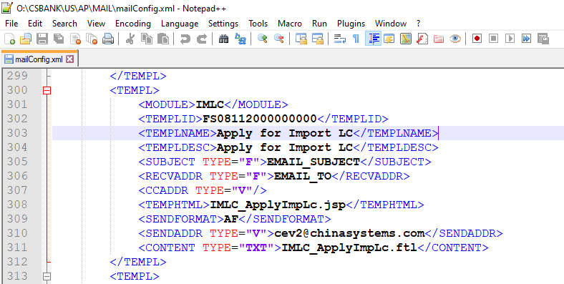

[Parameter Folder]\REPORTTMPL\US

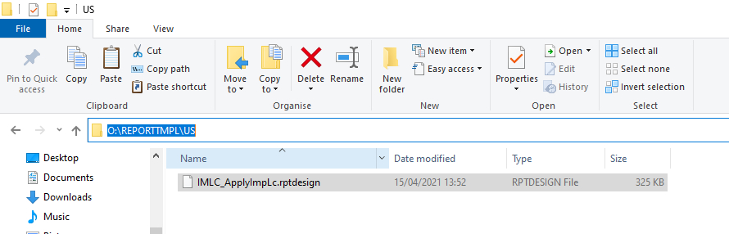

The EntityOutPutConfig.xml file may be configured using the following details:

|  |  |  |
| --- | --- | --- |
| Output | | Head Node |
| MAILTEMPLATE  Configure ‘by  bank/region’ options  for mail templates | MAILTEMPLATE@BYBANK | This attribute is a global setting for all mail templates.   * Y: Use different mail templates by bank (different {BANK} folder) * N: Use a common mail template for all banks. It is the default value. |
| MAILTEMPLATE@BYREGION | This attribute is a global setting for all mail templates.   * Y: Use different mail templates by region (different {REGION} folder) * N: Use a common mail template for all regions. It is the default value. |
| MAILTEMPLATE>TEMPLNAME | This attribute is a special setting for specified mail template. The settings are prior to the global setting.  Specify the mail template name |
| TEMPLNAME@BYBANK | This attribute is a special setting for specified mail template.   * Y: Use different mail templates by bank (different {BANK} folder) * N: Use a common mail template for all banks. It is the default value. |
| TEMPLNAME@BYREGION | This attribute is a special setting for specified mail template.   * Y: Use different mail templates by region (different {REGION} folder) * N: Use a common mail template for all regions. It is the default value. |
| CATALOGEXPORT  Configure ‘by  bank/region’ options  for catalog export  templates | CATALOGEXPORT@BYBANK | This attribute is a global setting for all catalog export templates and related files (CSS, FTL, etc.)   * Y: Use different templates by bank (different {BANK} folder) * N: Use a common template for all banks. It is the default value. |
| CATALOGEXPORT@BYREGION | This attribute is a global setting for all catalog export templates and related files (CSS, FTL, etc.)   * Y: Use different templates by region (different {REGION} folder) * N: Use a common template for all regions. It is the default value. |
| CATALOGEXPORT>PDF | This attribute is a special setting for specified file format. The settings are prior to the global setting.   * PDF: define ‘by bank/region’ options for CSS of PDF template. * Excel: define ‘by bank/region’ options for Excel template file. * HTML: define ‘by bank/region’ options for FTL template file. |
| CATALOGEXPORT>EXCEL |
| CATALOGEXPORT>HTML |
| BIRTREPORT  Configure ‘by  bank/region’ options  for BIRT templates | BIRTREPORT@BYBANK B | This attribute is a global setting for all BIRT templates.   * Y: Use different BIRT templates by bank (different {BANK} folder) * N: Use a common BIRT template for all banks. It is the default value. |
| BIRTREPORT@BYREGION | This attribute is a global setting for all BIRT templates.   * Y: Use different BIRT templates by region (different {REGION} folder) * N: Use a common BIRT template for all regions. It is the default value. |
| BIRTREPORT>TEMPLATENAME | This attribute is a special setting for specified BIRT template.  The settings are prior to the global setting.  Specify the BIRT template name |
| TEMPLATENAME@BYBANK | This attribute is a special setting for specified BIRT template.   * Y: Use different BIRT templates by bank (different {BANK} folder) * N: Use a common BIRT template for all banks. It is the default value. |
| TEMPLATENAME@BYREGION | This attribute is a special setting for specified BIRT template.   * Y: Use different BIRT templates by region (different {REGION} folder) * N: Use a common BIRT template for all regions. It is the default value. |

sys_extend_session_fields.xml

Manually add the field <REG_CNT_CD/> under <SEC_BUSINESS_UNIT> in the sys_extend_session_fields.xml file. This file is stored on the following path:

[Parameter Folder]\CE_SYS\SYST

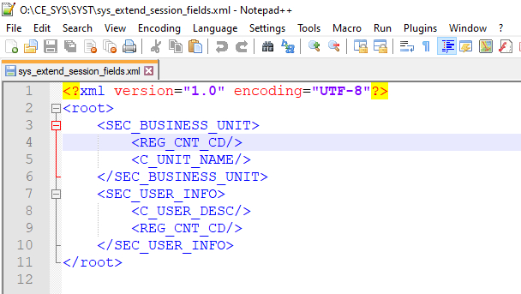

Procedures

In these sample procedures, the following initial settings are configured:

* The value of the BYREGION security parameter is set to TRUE. The xml file that contains the details of security parameters is the sys_para.xml file, which is stored on the path: [Parameter Folder]\CE_SYS\SYST

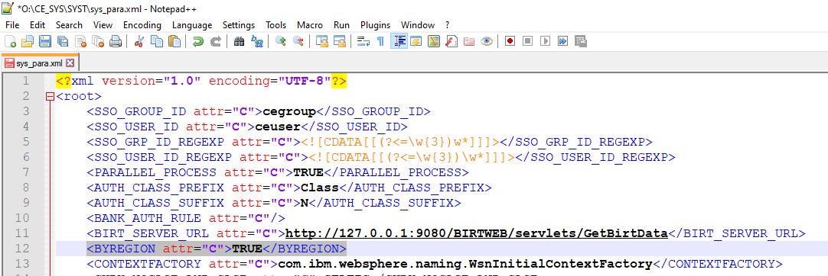

* In the EntityOutputConfig.xml file, the mail, catalog export, and report templates are set to by region (i.e., BYREGION=“Y”). This file is stored on the path: [Parameter Folder]\CE_SYS

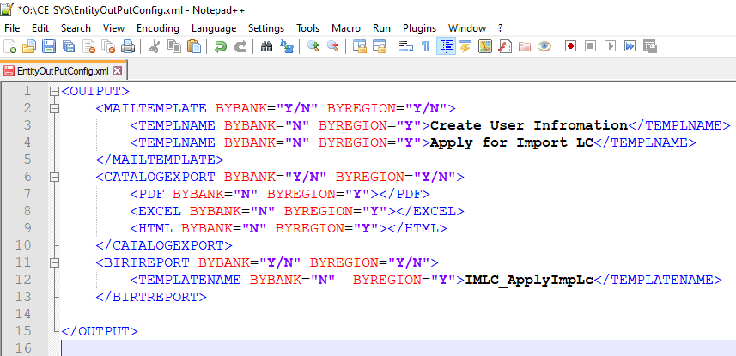

Mail Templates

To use different mail templates based on entity (i.e., regional country code):

|  |
| --- |
| Do the following . . . |

|  |  |  |
| --- | --- | --- |
|  |  | *Mail Template* |
|  |  |  |
| 1. In this example, there are two regions in the system: CN and US. Folders must be created to be used to store templates for different regions.  **NOTE:**  All the templates have the same name. |  |  |
|  |  |  |
| 2. Add the mail templates in the CN folder. |  |  |
|  |  |  |
| 3. Add the mail templates in US folder. |  |  |
|  |  |  |
|  |  | *E-mail notification in transaction module*  *(Regional Country Code= ENBD_AE)* |
|  |  |  |
| 4. Log on the CE system as an operator user (e.g., ENBDAEOP1) with the ENBD_AE regional code.  Run the Apply for Import LC function. |  |  |
|  |  |  |
| 5. Confirm the transaction.  Click on the View Mail button in the success page. |  |  |
|  |  |  |
| 6. The mail content is same as the mail template for the ENBD_AE region. |  |  |
|  |  |  |
|  |  | *E-mail notification in Security module*  *(Regional Country Code= CN)* |
|  |  |  |
| 7. Log on the CE system as an administrator user (e.g., ENBDADMIN01) which regional code is ENBD_AE.  Run the Add Operator function. Process and confirm a transaction. |  |  |
|  |  |  |
| 8. Authorise the transaction.  The mail is received by the relevant user. The content of the mail is sent based on the mail template set for the ENBD_AE region. |  |  |
|  |  |  |
|  |  | *E-mail notification in Security module*  *(Regional Country Code= US)* |
|  |  |  |
| 9. Log on to the CE system as an administrator user (e.g., EIBADMIN01) which regional code is EIB_AE.  Run the Add Operator function. Process and confirm a transaction. |  |  |
|  |  |  |
| 10. Authorise the transaction.  The mail is received by the relevant user. The content of the mail is sent based on the mail template set for the EIB_AE region. |  |  |

Catalog Export

To use different catalog export settings based on entity (i.e., regional country code):

NOTE: For information on configuring the related Export template parameters, refer to the Export Setting function discussion in the *CE Utility Reference: Transaction Functions* manual.

|  |
| --- |
| Do the following . . . |

|  |  |  |
| --- | --- | --- |
| 1. In this example, there are two regions in the system: CN and US. Folders must be created to be used to store templates for different regions.  **NOTE:**  All the templates have the same name. |  |  |
|  |  |  |
| 2. Add the export templates in the CN folder. |  | * Template for Print (e.g., Print.ftl):      * Template for PDF (e.g., TemplateofPDF.css):      * Template for Excel (e.g., TemplateofExcel.xls): |
|  |  |  |
| 3. Add the export templates in the US folder. |  | * Template for Print (e.g., Print.ftl):      * Template for PDF (e.g., TemplateofPDF.css):      * Template for Excel (e.g., TemplateofExcel.xls): |
|  |  |  |
|  |  | *Catalog Export in transaction module*  *(Regional Country Code= CN)* |
|  |  |  |
| 4. Log on to the CE system as an operator user (e.g, CHINAOP01) which regional code is CN.  Run the View Import LC function.  Click on the relevant export button for Print, Excel, or PDF. |  |  |
|  |  |
|  | Exporting the catalog as Print |
|  |  |
|  | Exporting the catalog in PDF format |
|  |  |
|  | Exporting the catalog in Excel format |
|  |  |  |
|  |  | *Catalog Export in transaction module*  *(Regional Country Code= US)* |
|  |  |  |
| 5. Log on to the CE system as an operator user (e.g, USOP01) which regional code is US.  Run the View Import LC function.  Click on the relevant export button for Print, Excel, or PDF. |  |  |
|  |  |
|  | Exporting the catalog as Print |
|  |  |
|  | Exporting the catalog as Print |
|  |  |
|  | Exporting the catalog in Excel format |

Report Template

To use different report templates based on entity (i.e., regional country code):

|  |
| --- |
| Do the following . . . |

|  |  |  |
| --- | --- | --- |
| 1. In this example, there are two regions in the system: CN and US. Folders must be created to be used to store templates for different regions.  **NOTE:**  All the templates have the same name. |  |  |
|  |  |  |
| 2. Add the report template in the CN folder. |  |  |
|  |  |  |
| 3. Add the report template in the US folder. |  |  |
|  |  |  |
|  |  | *Report Template in transaction module*  *(Regional Country Code= CN)* |
|  |  |  |
| 4. Log on to the CE system as an operator user (e.g., CHINAOP01) which regional code is CN.  Run the Apply for Import LC function. |  |  |
|  |  |  |
| 5. Confirm the transaction.  Click on the View Report button in the success page. |  |  |
|  |  |  |
| 6. The report is generated using the report template added in the CN region. |  |  |
|  |  |  |
|  |  | *Report Template in transaction module*  *(Regional Country Code= US)* |
|  |  |  |
| 7. Log on to the CE system as an operator user (e.g., USOP01) which regional code is US.  Run the Apply for Import LC function.1. |  |  |
|  |  |  |
| 8. Confirm the transaction.  Click on the View Report button in the success page. |  |  |
|  |  |  |
| 9. The report is generated using the report template added in the US region. |  |  |

Glossary

Glossary

Glossary

a

|  |  |
| --- | --- |
| ***Administrator*** | The type of CE Utility user with rights to create Administrator and Operator users and define transaction function parameters such as GAPI rules, SWIFT settings, and accounting rules. |
|  |  |
| ***Application Server*** | Server on which the CE system is actually deployed and on which CE processes the business logic and parameter operations. |
|  |  |
| ***Attribute*** | Pertains to a Business component. Its specific settings regulate the behavior of functions in processing transactions. Unlike the main program (Control component), which provides the general purpose of the function, attributes define the actual actions to be performed by the function. A function may use several attributes; this group of one or more attributes is called an Attribute rule. |

B

|  |  |  |  |  |  |
| --- | --- | --- | --- | --- | --- |
| ***BIRT*** | | | | Stands for Business Intelligence and Reporting Tools. It is an Eclipse-based open source reporting system for web applications that provide a variety of reporting design options and report patterns in different file output formats. This application is embedded in CE as a report engine type to be used for the generation of reports and documents. | |
|  | | | |  | |
| ***BIRT Designer*** | | | | A report template layout designer tool used to create a professional and consistent design for generating reports. | |
|  | | | |  | |
| ***BIRT EAR File*** | | | | The required file to deploy the BIRT application. This file contains the required XML files and the BIRT.war folder, which is composed of the BIRT configuration properties, the CSS files, and the JAR files that are used to configure the BIRT application. | |
|  | | | |  | |
| ***BIRT_LOG_PATH*** | | | | The field used to define the BIRT log path. | |
|  |  | | | |
| ***BIRT_LOG_LEVEL*** | | | The field used to define the BIRT log level: Severe, Warning, Info, Config, Fine, Finer, Finest, All, or Off. |
|  | | |  |
| ***BIRT Report Template*** | | | It defines a basic report structure on which generated reports are based. |
|  | | |  |
| ***BIRT_SERVER_URL*** | | | A system parameter that defines the URL of the BIRT Server. |
|  | | |  |
| ***BIRT.war*** | | | This file must be included in the CE.ear file if CE and BIRT are to be installed in the same application server and are to use the same .EAR file. |

C

|  |  |  |  |
| --- | --- | --- | --- |
| ***Catalog*** | | | A set of criteria that is used for filtering the records to be retrieved into, and subsequently processed in, a transaction function. |
|  | | |  |
| ***CE Baseline*** | | | The CE data and processing model for the trade finance and supply chain services of a customer (company). It consists of modules that can be executed readily to produce the required output or action. |
|  | | |  |
| ***CE Document*** | | | Generally refers to a report form that displays transaction details based on the defined Form and Report Template settings. It is generated during transaction processing but can be viewed after the transaction has been authorized. |
|  | | |  |
| ***CE Output Directory*** | | | Pertains to the directory on which reports are generated. |
|  | | |  |
| ***CE Utility*** | | | Short for Customer Enterprise Utility Workbench. This is the main tool for building parameters in CE. |
|  | | |  |
| ***CEWeb.war*** | | | The folder that contains the business parameter files which are in the original format as JS or JSP. |
|  | | |  |
| ***CE.ear*** | | | The main file required in order to deploy and install Customer Enterprise. |
|  | | |  |
| ***CE_PARA*** | | | The folder that contains the business parameter files which are in an XML file format. |
|  | | |  | |
| ***Client*** | | | The CE system’s user browser interface. | |
|  |  | | |
| ***CS Eximbills (CSX)*** | | | The Eximbills core back-office application that runs on client-server technology. It is a fully integrated system designed to automate the complete trade finance processing cycle as well as communicate the requirements of the parties involved in a trade finance transaction. |
|  | | |  |
| ***Customer Enterprise (CE)*** | | | The Eximbills business-to-business (B2B) solution that provides bank customers with a convenient and secure single window for processing and inquiring on all their trade finance, open account, and payments transactions. |
|  | | |  |
| ***Customer Enterprise***  ***Utility Workbench*** | | | See CE Utility. |

D

|  |  |
| --- | --- |
| ***Data Source*** | A source of digitized data (e.g., database, connection to a database). |
|  |  |
| ***Document*** | See Transaction Document*.* |

E

|  |  |
| --- | --- |
| ***Eclipse*** | An open-source software used as the BIRT Report Designer application. |
|  |  |
| ***End-user*** | The actual user running the CE business functions. |
|  |  |
| ***Event*** | A grouping of activities that occur in the life cycle of a specific type of transaction. |
|  |  |
| ***Eximbills*** | The flagship product of China Systems, which provides support for advanced e-commerce, open account, and trade-related services. |
|  |  |
| ***Eximbills Enterprise (EE)*** | The Eximbills integrated system that runs on Java EE. It automates and audits the complete cycle of Trade Finance, Open Account, and Payments transactions, in real time and in accordance with SWIFT, UCP, and ISO20022 standards. |

F

|  |  |  |  |  |
| --- | --- | --- | --- | --- |
| ***Field*** | | | The smallest unit that can hold data. | |
|  |  | |
| ***Form Rule*** | | | Pertains to the rule or settings for creating document forms. This is defined in the Form function of the CE Utility. |
|  | | |  |
| ***Function*** | | | A unified set of elements, operations, and configurations that produce a target setting, process, and/or output. This typically refers to a CE Utility function or a transaction function. |
|  | | |  |
| ***Function JS file*** | | | A JS file that contains the function level methods, calculations and validations that control the behavior of specific fields in a transaction page. |
|  | | |  |
| ***Function Group*** | | | A grouping of CE browser-side functions that is organized based on the common usage and purpose of the functions. A function group is set up in the CE Utility. |

G

|  |  |
| --- | --- |
| ***GEN_WEB_ROOTPATH*** | The system parameter that is used to define the path of the WEB parameter files. It is a Utility Workbench type of system parameter, which is defined through the System Parameter function in the CE Utility. |
|  |  |
| ***GEN_XML_ROOTPATH*** | The system parameter that is used to define the path of the XML parameter files. It is a Utility Workbench type of system parameter, which is defined through the System Parameter function in the CE Utility. |

H

|  |  |
| --- | --- |
| ***HTML*** | Stands for Hyper Text Markup Language; the main markup language for web pages, HTML elements are the basic building-blocks of web pages. It consists of tags enclosed in angle brackets within the web page content, and has start tags (opening tags) and end tags (closing tags). In between these tags are text, tags, comments and other types of text-based content. |
|  |  |
| ***HTTPS*** | Stands for Hypertext Transport Protocol Secure, a variant of the standard HTTP. It is a protocol for secure communication over a computer network. |

I

|  |  |
| --- | --- |
| ***IBM WebSphere Application***  ***Server*** | The application server service by IBM WebSphere that facilitates the operation and maintenance of the application processes of systems such as CE. |

J

|  |  |
| --- | --- |
| ***JavaScript*** | A scripting language that can interact with HTML source codes and has dynamic content. |

K

|  |  |
| --- | --- |
| ***Key Fields*** | The fields that, when combined together, make each of the records of a table unique. The key fields that are automatically added to the table must be retained to ensure proper runtime processing. |

L

|  |  |
| --- | --- |
| ***Letter of Credit*** | A document that is issued by a bank stating its commitment to pay the Exporter (or Seller) a stated amount of money on behalf of an Importer (or Buyer) so long as the Seller meets specific documentary terms and conditions. The Buyer applies for a letter of credit from his bank (the Issuing Bank) in favor of the Seller (the Beneficiary of the letter of credit). The Seller’s bank (the Advising Bank) advises the Seller of the receipt of the letter of credit. |

M

|  |  |
| --- | --- |
| ***Main Program*** | Pertains to a Control component. It indicates the primary operation to be performed by a transaction function and determines the parameter and control rules to be used once the transaction function is initialized and confirmed. |
|  |  |
| ***Maintenance Function Group*** | A function group composed of functions that are used for maintaining the tables, fields, and files that are used in the CE Utility. |
|  |  |
| ***Module*** | A group of functions that perform interrelated processes and operate under a general principle or objective (e.g., a system module, which is essential to system processes; a business or transaction module, which pertains to a bank service or product). |

O

|  |  |
| --- | --- |
| ***Operator*** | The type of CE Utility user with parameter and transaction module configuration rights. |
|  |  |
| ***Oracle*** | A database server product that is compatible with the CE system. |
|  |  |
| ***Output Device Function*** | The CE Utility function that is used to define parameters and rules that instruct the system on handling transaction output using the devices such as printers, faxes, and e-mail. |
|  |  |
| ***Output directory*** | The repository of all documents and reports generated through BIRT |

P

|  |  |
| --- | --- |
| ***Parameter*** | Any user-controlled configuration that defines a factor or logic within a set of interrelated operations; performs a specific action in a group of processes; or produces a categorical result or setting. |
|  |  |
| ***Parameter Drive*** | The location of the CE parameter files, one of the two main folders of an CE environment. Its path is defined in the GEN_XML_ROOTPATH system parameter. |
|  |  |
| ***Product*** | The actual functionality accessed and run by the end-user. This process of creating a product involves setting up the product group, product and product function and defining product catalog settings. |
|  |  |
| ***Product Function*** | The counterpart of transaction function in browser processing. It is the function that the end-user access at runtime. |
|  |  |
| ***Product Function Setting*** | The Product Function Setting from the Product function group is used to configure the settings for defining Product Groups, Products and Product Functions. |

R

|  |  |
| --- | --- |
| ***Record*** | Pertains to the transaction. |
|  |  |
| ***ReportEngine*** | A folder provided in the system release and is required for the installation of the BIRT template. |
|  |  |
| ***REPORTTMPL*** | A folder required for the installation of the BIRT template. All BIRT report template files are stored in this folder. |
|  |  |
| ***Report Template*** | Templates that are created to be incorporated to the CE Directory for the system to generate the relevant report. |

S

|  |  |
| --- | --- |
| ***Schema*** | The structure and layout of objects within the database. In Oracle, a schema is associated with a specific database user and is comprised of database objects such as tables and views. |
|  |  |
| ***Screen*** | A function’s transaction screen. This is the actual webpage displayed when running a function in the CE browser. |
|  |  |
| ***SQL*** | Stands for Structured Query Language. This is a standard interactive and programming language for retrieving and updating data in the database. |
|  |  |
| ***Super Administrator*** | The type of CE Utility user with rights to administrative tasks such as configuring business units; defining data sources; and creating Super Administrator and Administrator user profiles. |
|  |  |
| ***System Date*** | The date used by the server on which the CE application is installed. |
|  |  |
| ***System Fields*** | Predefined fields that are used by the system. Such fields are automatically added to a transaction table according to the transaction table type (e.g., Master, Event, and Ledger). There are of two types of system fields: System Control fields, which are listed in the DataDic.xml file, and System Transaction fields, which are imported from standing data tables. |
|  |  |
| ***System Function Group*** | The CE Utility function group that is comprised of functions, which are used for maintaining and facilitating system-wide tasks. |
|  |  |
| ***System Maintenance Module*** | A module for system maintenance operations. This includes functions for opening and closing a business day, running batch tasks, and viewing logs among others. |
|  |  |
| ***System Parameters*** | The references or values that are defined to control the behavior of CE during transaction processing on the browser and in the CE Utility. |

T

|  |  |
| --- | --- |
|  |  |
| ***Transaction Database*** | The main database utilized by CE. It contains system, security, standing, parameter, and transaction data. |
|  |  |
| ***Transaction Document*** | Also referred to as form. It is one of the types of output that can be generated in HTML, PDF, WORD, or EXCEL format by a transaction function. |
|  |  |
| ***Transaction Fields*** | User-defined fields for use in transaction module tables. |
|  |  |
| ***Transaction Function*** | The CE Utility function group that consists of functions used for defining the actual business parameters of transaction functions. See Function also. |
|  |  |
| ***Transaction Report*** | Refers to a set or batch of summarized data generated through a standalone report function. |
|  |  |
| ***Transaction Screen*** | See Screen. |
|  |  |
| ***Transaction Tables*** | Also referred to as module tables. Data used by a module are stored into and retrieved from module tables. Through the DB Dictionary function in the CE Utility – a table is created, assigned to a schema, and reformatted in order to physically create and commit the table to the database. |

W

|  |  |
| --- | --- |
| ***Web Server*** | The server that receives data from the client (i.e., JSP and JS details), converts ist to XML format, passes it to the application server for processing, and passes the processed info from the application server to the client. |

X

|  |  |
| --- | --- |
| ***XML*** | Stands for Extensible Markup Language. This is the format used by CE for the communication between the client (browser) and the server. |
|  |  |
| ***XML Generator Function*** | The CE Utility function that is used to generate the corresponding XML files for a specific parameter setting. |